COMPASS Report Editor
Function SetPassFail
Check the status of each point and list PASS or FAIL and determine an overall test Pass/Fail value.
This is useful is you want to log default COMPASS Status (blank, T, R, r, t) in datafile
but also want to show Pass or Fail in report for Status
First copy the text below on page 2 to a new DataFile macro and name it SetPassFail.
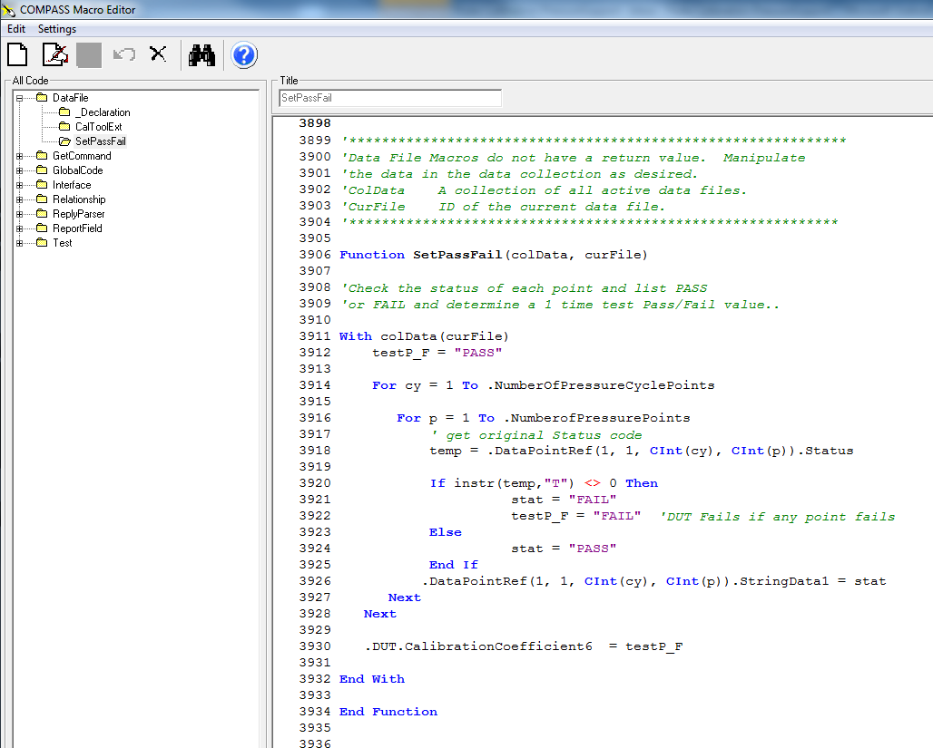
Macro changes status to PASS or FAIL
testP_F status is status of overall test. If one point fails, test fails.
SetPassFail is a DataFile macro
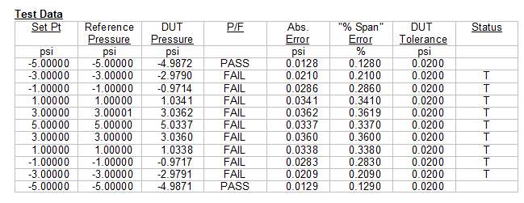
Default status, good to have in datafile for troubleshooting but confusing in report.

'*************************************************************
'Data File Macros do not have a return value. Manipulate
'the data in the data collection as desired.
'ColData A collection of all active data files.
'CurFile ID of the current data file.
'************************************************************

Function SetPassFail(colData, curFile)

'Check the status of each point and list PASS or FAIL
'and determine overall Pass/Fail value for each Pressure Cycle

With colData(curFile)
'Pressure Cycle Status set to PASS unless a point in the test failed
testP_F = "PASS"

'Determine overall pressure cycle Pass/Fail status
For cy = 1 To .NumberOfPressureCyclePoints

'Determine status of each point
For p = 1 To .NumberofPressurePoints
' get original Status code
temp = .DataPointRef(1, 1, CInt(cy), CInt(p)).Status

If instr(temp,"T") <> 0 Then
stat = "FAIL"
testP_F = "FAIL" 'DUT Fails if any point fails
Else
stat = "PASS"
End If

'Set status of each point
.DataPointRef(1, 1, CInt(cy), CInt(p)).StringData1 = stat
Next
Next

'Set Pressure Cycle Status to DUT Cal Coef 6 and can show in Report
.DUT.CalibrationCoefficient6 = testP_F

End With

End Function

Put Stringdata1 field into the COMPASS Report Editor Template and select SetPassFail as a Template Macro. Double-click on Template Macros to open the Template Macros window and then double-click the SetPassFail macro on the left “Available Macros” to move it to the right “Selected Template Macros”.
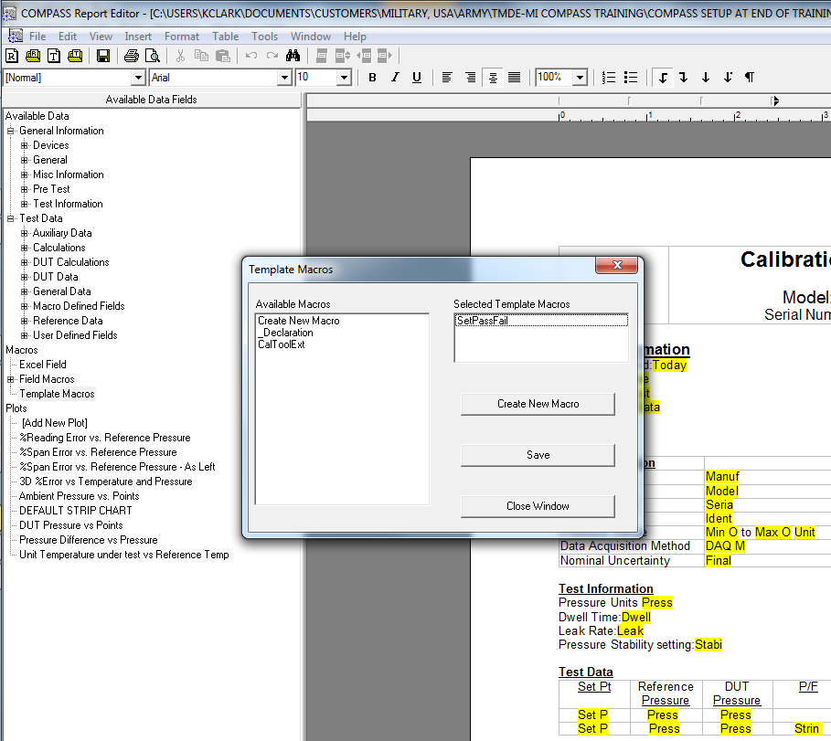
String Data 1 here
SetPassFail macro is selected
Add or edit the table in the template so String Data 1 is used for Status.
String Data 1 comes from “Available Data” -> “Test Data” -> “User Defined Fields” -> “String Data 1”
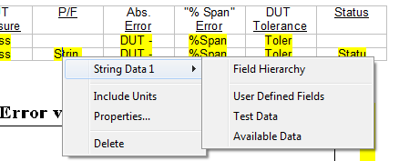
In the String Data 1 Properties window make sure Individual Data Point is set to 0 so Status is shown for all setpoints in the datafile.
Uncheck the box “Use PASS/FAIL for the status of each test point.” The macro will set PASS/FAIL for you now.
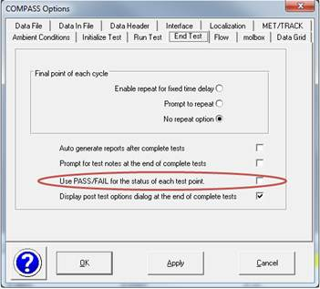
Note that if you want to use this macro on another computer you also have to transfer the macro and not just the template file. Use the [Database], <COMPASS Database Management Tool> to copy the macro to another database.
