Irisys Bluetooth Setup Module

User Guide

Irisys Bluetooth Setup Module User Guide

1. Introduction 3
1.1. About 3
1.2. How to Use This Guide 3
1.3. Software Version History 3
1.4. Hardware Requirements 4
1.5. Bluetooth Setup Module Usage 4
1.6. Prerequisites 5
1.7. Bluetooth Setup Module Required Information 5
1.8. Bluetooth Setup Module to Counter - Physical Connection 6
1.8.1. Bluetooth Setup Module to Gazelle Counters 6
1.8.2. Bluetooth Setup Module to 3000 series Counters 7
2. Configuring Your Laptop 8
2.1. Counter to Laptop Connection Via Bluetooth 8
2.2. Laptop Bluetooth Adapter Drivers 8
2.3. Enabling Bluetooth on your Laptop 9
3. Bluetooth Pairing 10
3.1. About 10
3.1.1. Already Paired? 10
3.2. Pairing Process 12
3.2.1. Errors during the Pairing Process 17
3.2.2. Bluetooth Setup Module Virtual COM Port 18
4. Using the People Counter Setup Tool (PCST) Software over Bluetooth 20
4.1. PCST Bluetooth Connection Failures 21
F.A.Q.s 22
Appendix A - The Pairing Process on Windows XP 24
Appendix B - Breaking a Bluetooth Bond 26

Introduction

About
Before use, the Irisys People Counters must be configured to work in their installed location. Set-up instructions and guidance are discussed in the relevant Irisys document Setup Software Manuals.
Connection to the counter for setup purposes is provided via local serial connection or, in the case of IP enabled units, via IP; either locally, or remotely across the internet.
With the new Bluetooth Setup module, part number IWC3095, a third method of connection is now available.
This document describes the steps involved when using the Bluetooth Setup Module to configure Irisys Gazelle and 3000 series people counters.

How to Use This Guide
This guide assists with the use of the Irisys Bluetooth Setup module for use in configuring Irisys 3000 and Gazelle series people counter units. It deals with the connection, setup and pairing of bluetooth devices, but does not go into specific counter setup once a connection is made.
Bluetooth devices must first be paired together and this is done solely through Windows requiring no additional software. If you are familiar with pairing of Bluetooth devices within a Windows environment then you probably do not need to read much of this guide, if any. But the pairing process can be tricky if you have not done it before and this is covered in section 2.
Also, if you have never previously configured any Irisys people counter units then it is recommended that the vast majority of this guide is read before attempting to use the Bluetooth Setup adapter with an Irisys unit. Those who have never configured an Irisys counter should read the additional installer and setup documentation available.
Official Irisys partners must undertake installer training prior to installation of Irisys counters to maintain their partner status.
Throughout this guide, a number of ‘boxouts’ will be shown at appropriate times:
This type of boxout denotes important information or instructions that must be followed.


This type of boxout denotes relevant information which may be of interest in certain applications.

This type of boxout denotes a useful piece of information (hints) that may not have been immediately obvious but which could be helpful in the future.

Software Version History
To form a Bluetooth connection between a counter and your laptop does not require any specific software, but it is always recommended that a Windows Update is performed in order to obtain any newer Bluetooth adapter drivers for your laptop, if available.
If utilising a plug-in Bluetooth adapter, it is strongly recommended that the very latest drivers are installed for this. These are usually available on the adapter manufacturer’s website; see section 2.2 for more details.
To configure the counters once a connection is made does require the People Counter Setup Tool software, and, again, it is always recommended that the very latest version is used. The latest version, at time of writing, is shown below:

People Counter Setup Tool (PCST) 3.0.41019.1

Hardware Requirements
The only specific hardware requirement is the obvious need for Bluetooth on your laptop. This can be built in to the laptop, or be provided by an external plugin USB adapter. This then connects to the Irisys Bluetooth Setup Module at the counter in order to form the connection.
The Irisys Bluetooth Setup Module cannot be used as a Bluetooth ‘dongle’ in order to provide a laptop with its own Bluetooth connection. It can only be connected directly to the counter and used in conjunction with a laptop which has built-in Bluetooth or a third party USB to Bluetooth adapter (or dongle).

Bluetooth Setup Module Usage
The Bluetooth Setup Module provides a hidden, wireless, RS232 serial connection to the indoor 3000 series and Gazlle series counters. There are a number of different variants in both ranges of Irisys people counter products, including units that are IP enabled, and units which are relay (pulse) output enabled. The Bluetooth Setup Module can be used with all indoor counter variants, including IP, relay, and dual view units.
The Bluetooth Setup Module cannot be used with outdoor units such as IRC3110, IRC3111 and IRC3113 units, etc.; older 1000 series units such as the IRC1004 counter; or with the IRS2100 tailgate detectior.

The Bluetooth Setup Module effectively provides an alternative method of configuring counters to using an IP connection or a cabled serial connection. It is effectively the equivalent of the cabled serial connection method, as it is used locally and provides exactly the same configuration options as if connected via a serial cable, but with the advantage of being a wireless connection.
Note that on IP enabled units, some settings, such as ‘Client Connection’ for example, can only be made via an IP connection.

The Bluetooth Setup Module can be used as a direct serial setup module or cable replacement; re-used on each counter installation, as required. Alternatively, it can be left permanently connected to a counter so as to facilitate easy access to that counters settings at any time. By leaving the module permanently connected, you will not need to obtain access to the counter on the ceiling in order to connect and disconnect a serial setup module each time you want to view the configuration settings or make changes. For this reason, the Bluetooth Setup Module is recommended for installations where obtaining access to the counter in the future could prove to be difficult or costly, for example, avoiding the requirement to work out of hours, or use expensive lift gear to access very high mounted units.
The Bluetooth Setup Module cannot be used to acquire count data from the counter it is connected to. The counter must be supplied with power and connected to an appropriate data logger or server on the network in order to extract count data; either via relays or the IP network as appropriate to the model of counter.
The Irisys Bluetooth setup Module does not provide for data retrieval via Bluetooth, it is purely for local wireless configuration of counter functionality only.

The Bluetooth Setup Module provides a wireless serial connection at a distance of up to 30m, dependant on obstacles in line of sight between the configuring laptop and the Bluetooth module itself. By mounting the module behind the counter this distance will be reduced. If mounting the module in the ceiling, this distance will be reduced even further (see section 1.8 for more details).
The Bluetooth Setup Module provides an alternative serial connection to:
The IWC3062 serial setup cable (used on IP units); IWC3052 setup module (used on relay units); and the IWC3059 back connecting setup module (used on IP and Relay units).

Prerequisites
It is assumed throughout this document that the counter that you want to connect to has been installed on the ceiling, and that the Bluetooth Setup Module will be used to configure the counter. This could be a one off configuration at which point the module is taken away and used at the next counter installation, or it could be left in place for easy setup access in future.
If required the Bluetooth Setup Module will work with units which are in a test environment; on someone’s desk, for example.
The counter must be supplied with power and connected to an appropriate data logger or server on the network in order to extract count data; either via relays or the IP network as appropriate to the model of counter.

Bluetooth Setup Module Required Information
Before connecting the Bluetooth Setup Module to a counter, first make a note of the information on the two labels on either side of the device. On the top label is the unique identifier for when more than one device is in range and you’re not sure which is which. The last six characters are displayed when first connecting to and pairing with a Bluetooth adapter:
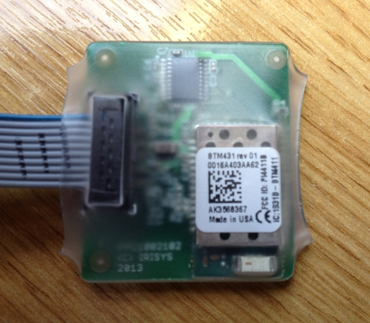
Figure 1.7.1

On the label on the reverse side of the module is the pairing code which will be requested when first connecting to and pairing with it:
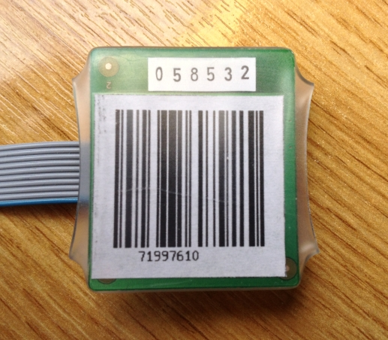
Figure 1.7.2

Make a note of the pairing code now before you install it with the counter on the ceiling and out of sight!

Bluetooth Setup Module to Counter - Physical Connection
The module connects to a counter via a 10 pin rectangular connector and the cable is long enough to allow the module to be installed inside the ceiling void above the counter or installed inside the counter base/housing if required, and providing there is enough room. You may need to reroute your main power and/or IP cables to accommodate the module.
On Gazelle units the 10 pin connector is hidden see appropriate section below.
The ribbon cable can also be cut down to a shorter size, if required, in order to help you with your chosen installation method. The short length trimmed cable is more appropriate for when installing inside the space in a counter’s base, and the longer full length cable is more likely to be of use when installing above the counter in the ceiling void for example. To trim the cable simply cut the cable using a sharp knife or pair of cutters. Once cut check that the cable is clean and the internal wires are not touching each other.
In some cases it may be necessary to enlarge the hole in the ceiling in order to install the Bluetooth Setup Module in the ceiling, especially if the cabling prevents in-base installation.

Bluetooth Setup Module to Gazelle Counters
The Bluetooth Setup Module connects to a Gazelle series unit via a hidden connector located behind a break out tab next to the main serial setup jack plug. Break the tab using a small screw driver to lever it out. Take care not to force the screw driver too far inside as you could damage the connector:
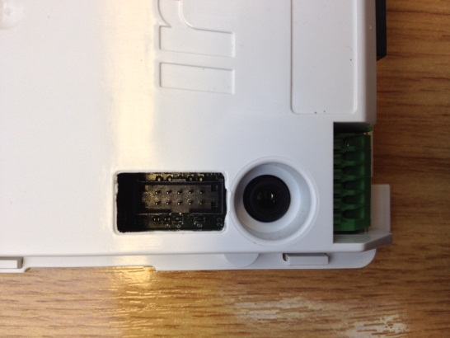
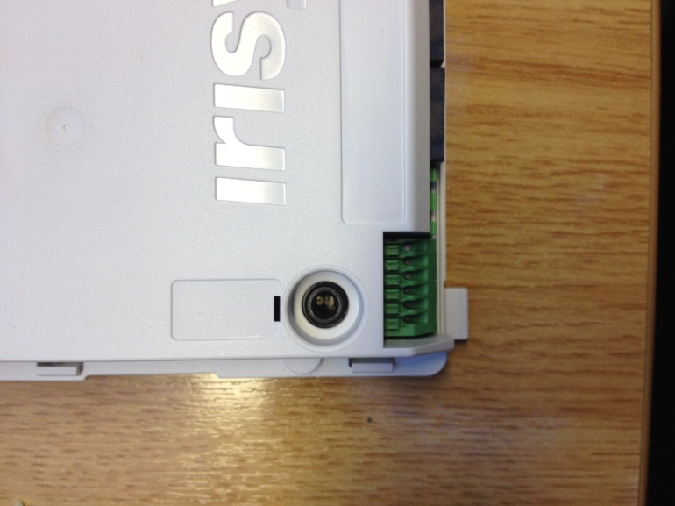
Figure 1.8.1

When connecting the Bluetooth module to a Gazelle unit, note that the connector is ‘keyed’ and will only connect one way around.
Once connected, install the Gazelle core module into its housing in location on the ceiling along with the module. The modules ribbon cable is long enough to be able to locate it next to the power and/or network/output cables, or the module can be installed in the ceiling void above the counter as required.
If installing the Bluetooth module inside the counter housing; ensure that it does not interfere or impede with placement of the front cover.
Note, when using the Bluetooth Setup Module to configure a Gazelle counter, the regular serial cable (IWC3062) cannot be connected as well. Connecting the Bluetooth Setup Module and regular serial cable to the same counter, at the same time, will stop both of them from working.

Bluetooth Setup Module to 3000 series Counters
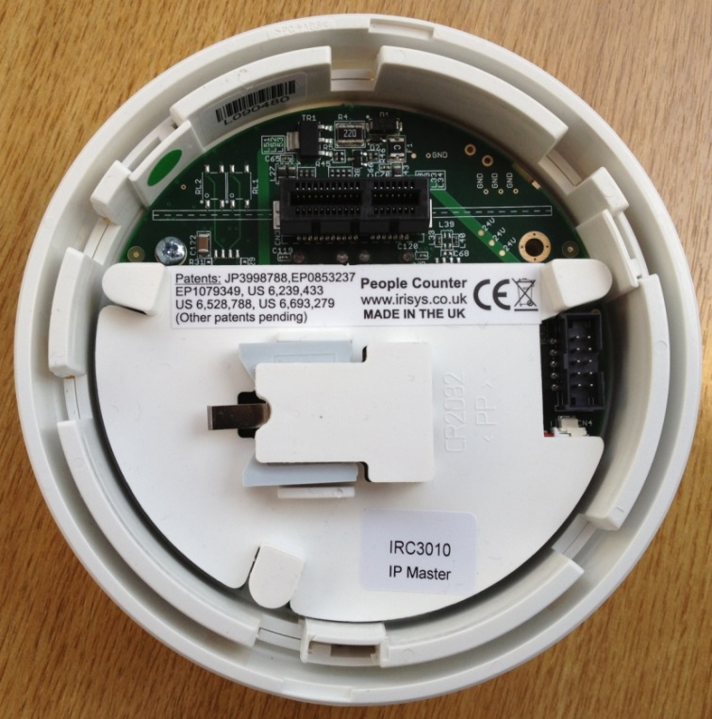
To connect the Bluetooth Setup Module to an Irisys 3000 series indoor people counter, take the counter head off its base and locate the rectangle 10 pin connector on the back of the unit. Now connect the ribbon cable from the module to this socket. As with Gazelle units, note that the connector is ‘keyed’ and so will only connect one way around:
Figure 1.8.2

Both the counter head and the Bluetooth Setup Module must now be installed back on the original base on the ceiling. To do this you will need to either guide the Bluetooth board up into the ceiling void, if appropriate (and there is a big enough hole), or install the Bluetooth board in the remaining space in the counter base, again, if there is room.
If connecting the Bluetooth Setup Module to a 3000 series relay unit, such as the IRC3020, you also have the option of installing it with the board sticking out through the slot in the base as is routinely done when configuring via the standard serial setup module. This is not recommended if you intend to leave it permanently connected.
Note, when using the Bluetooth Setup Module to configure a 3000 series IP counter, the regular serial cable (IWC3062) cannot be connected as well. Connecting the Bluetooth Setup Module and regular serial cable to the same counter, at the same time, will stop both of them from working.

Configuring Your Laptop

Counter to Laptop Connection via Bluetooth
When connected and setup correctly, a Bluetooth link will be formed between the counter and the laptop, over which serial data can be transmitted. This allows the standard People Counter Setup Tool (PCST) software to communicate with the counter for configuration purposes.
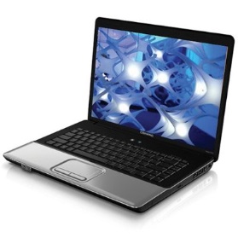
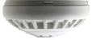
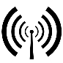
Counter & Bluetooth Adapter Module
Laptop Running PCST Software
Figure 2.1.1

Remember that for this to work correctly, the Irisys Bluetooth Setup Module must be connected to the counter and receiving power, but also the laptop itself must have its own Bluetooth adapter (either built-in or a third party plug-in module) which is installed and configured correctly, see following sections.

Laptop Bluetooth Adapter Drivers
Before you can do anything with the Bluetooth on your laptop you must ensure that the Bluetooth software driver is installed on your operating system – note, this is the driver for your laptop’s Bluetooth adapter, and not the driver for the Irisys Bluetooth Setup Module. If Bluetooth is built-in to your laptop then the Bluetooth drivers should already be installed by the manufacturer when you bought it. But if you are using a third party plug-in USB to Bluetooth adapter, then they may not be installed already. For plug-in adapters you should follow the instructions provided with your adapter to ensure that the drivers are installed correctly.
Remember that we are referring to the Bluetooth adapter drivers for your laptop’s own Bluetooth connection in this section - not any drivers for the Irisys Bluetooth module.

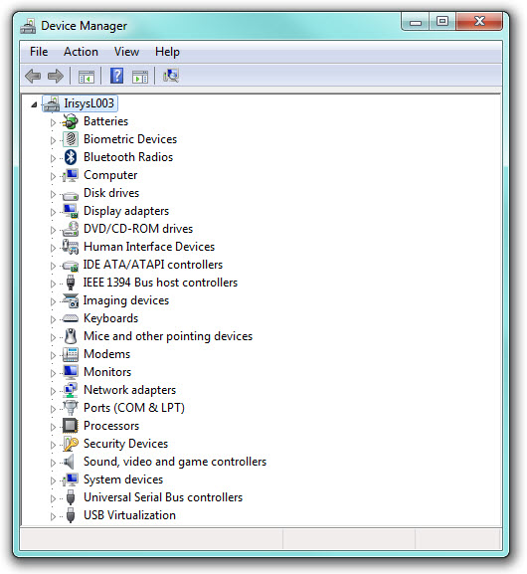
To check that the drivers are installed correctly simply go into the ‘Device Manager’ option from the Windows ‘Control Panel’, and check for any yellow exclamation marks next to any of the entries:
Figure 2.2.1 – No Yellow Exclamation Marks

Any exclamation marks shown next to any Bluetooth devices will almost certainly prevent connection to the Irisys Bluetooth Setup Module and so these problems should be investigated and fixed before continuing.
It is also recommended that any exclamation marks shown next to any device (not just Bluetooth devices) are investigated and corrected in order to ensure system stability.

There could be multiple Bluetooth entries listed but check to make sure that there are some Bluetooth drivers installed. There could be entries in the main list and/or located in one or more of the sections, for example, the Network Adapters section, as shown below. This will be different for each make and model of laptop and Bluetooth adapter.
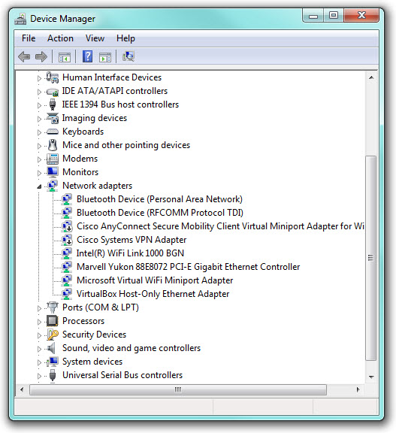
There could be additional entries in other sections such as ‘Ports (COM & LPT)’ or the USB section, especially if they are third party USB adapters. Make sure that they are all installed correctly with no exclamation marks:
Figure 2.2.2

If you are having trouble resolving a driver problem, contact your IT department or check the support section of your laptop, or Bluetooth, provider’s website.

Enabling Bluetooth on your Laptop
If you are using a laptop with built in Bluetooth, this may be switched off by default and you will need to switch it on before you will be able to use it. The way to switch on the Bluetooth signal is different on each brand of laptop, and could just be a switch or button that must be pressed, or held down for a few seconds, or it could be enabled by utilising a software application on your laptop. Some laptops utilise both methods and either can be used. Check the instructions that came with your laptop to see what you need to do.
For plugin USB to Bluetooth adapters, switching them on is usually just a simple case of plugging them in to your laptop. Ensure that Windows recognises the adapter properly and installs any drivers correctly, as above in section 2.2.
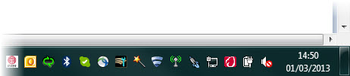

When Bluetooth is enabled, you may see an LED which illuminates, or possibly a tray icon as shown below:
Figure 2.3.1

Once Bluetooth is enabled you can begin the pairing process.

Bluetooth Pairing

About
Many of the services offered over a Bluetooth connection can expose private data or allow the connecting party to control the Bluetooth device. For security reasons it is therefore necessary to be able to recognize specific devices and thus enable control over which devices are allowed to connect to a given Bluetooth device.
To prevent unsecure or malicious control of Bluetooth devices and connections, a process called bonding is used, and a bond between two Bluetooth devices is created through a process called pairing.
The pairing process is triggered either by a specific request from a user to create a bond (for example, the user explicitly requests to "Add a Bluetooth device"), or it is triggered automatically when connecting to a service where (for the first time) the identity of a device is required for security purposes. These two cases are referred to as dedicated bonding and general bonding respectively.
Pairing usually involves some level of user interaction; this user interaction is the basis for confirming the identity of the devices. Once pairing successfully completes, a bond will have been formed between the two devices, enabling those two devices to connect to each other in the future without requiring confirmation of identity again. Usually, once paired, a connection is formed automatically as soon as devices are in range. If desired, the bonding relationship can be removed by the user to prevent a connection in the future (see Appendix B - Breaking a Bluetooth Bond).
All Bluetooth devices must be paired before they will communicate with each other and operate correctly.
As long as Bluetooth is enabled and functioning correctly on your laptop you can proceed with the Bluetooth pairing process. If you have ever paired a Bluetooth headset to a mobile phone, then the pairing process in Windows will be very familiar.

Already Paired?
Once two Bluetooth devices have been paired you will not need to do it again unless you purposely break the bond between the devices by telling one to ‘forget’ the other (see Appendix B - Breaking a Bluetooth Bond).
You can check which Bluetooth devices have already been paired and are connected to your laptop very easily.
If you have a Bluetooth icon in your system tray, this will usually be the simplest way of checking for active Bluetooth Devices. Simply right click the Bluetooth icon and select the ‘Show Bluetooth Devices’ option:
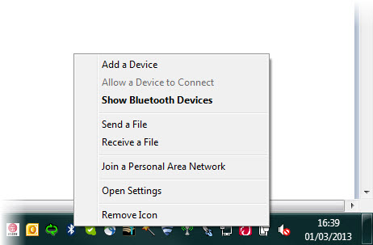
Figure 3.1.1

The Bluetooth Devices window will show you what, if any, Bluetooth devices have already been paired successfully:
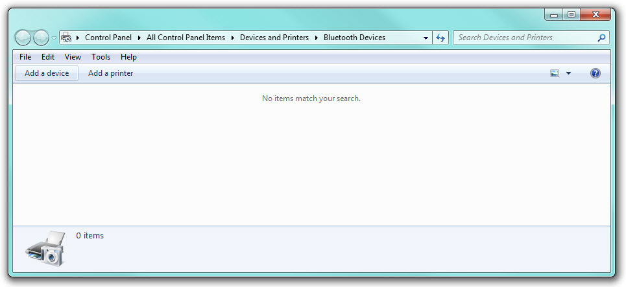
Figure 3.1.2

Any Irisys Bluetooth Setup Modules which have been paired and are in range can be identified with the Irisys prefix:
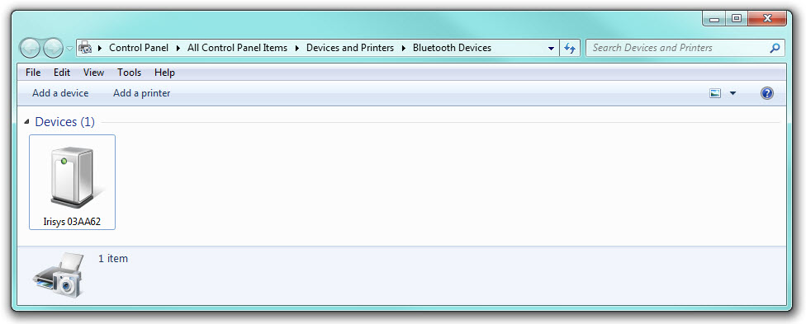
Figure 3.1.3

The six characters at the end of the device label refers to the physical label on each Module, see section 1.7.

Pairing Process
To begin the pairing process, locate the option for adding a new Bluetooth device on your computer. This may be in multiple locations and/or accessed via different methods dependent on your laptop, Windows version and what software may already have been installed previously.
Step 1A
If you have a Bluetooth icon in your system tray, this will usually be the simplest way of beginning the process. Just right click on the Bluetooth icon and select the ‘Add a Device’ option:

Figure 3.2.1

If this option is available to you, select it and then skip ahead to Step 2, if not, go to step 1B.

Step 1B
If your laptop does not have a Bluetooth icon in the system, then you will need to navigate to the correct option in the Windows ‘Control Panel’. Select ‘Devices and Printers’:
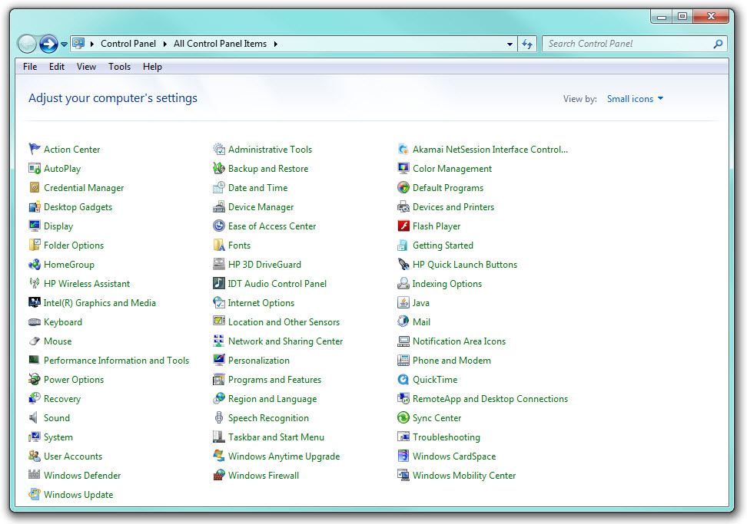
Figure 3.2.2

After a short pause the Devices and Printers window will populate with any currently attached devices.

Next, click the ‘Add a device’ button:

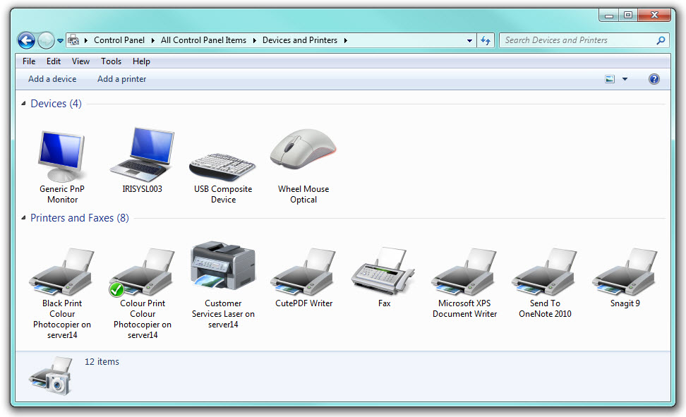
Figure 3.2.3

Step 2
The ‘Add a device’ dialog window will now open, and Windows will start searching for any new devices automatically:

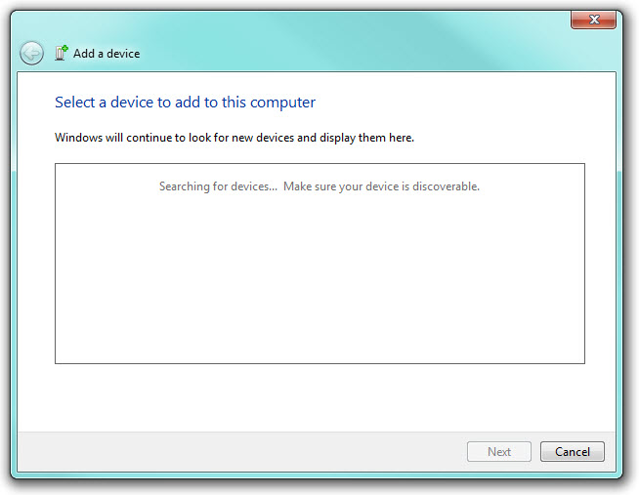
Figure 3.2.4

Ensure that the Bluetooth Setup Module is connected to the counter and that the counter is powered up and operational (indicated by LED activity).

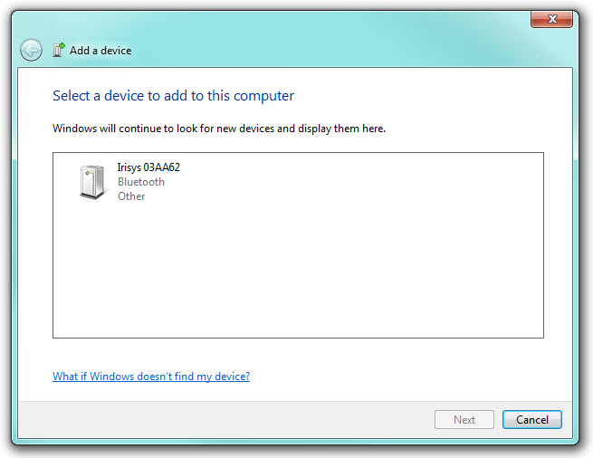
After a few seconds, the Irisys Bluetooth Setup Module should be found and displayed in the window. Note that the description of the device will always include the last six characters of the unique identifier as shown on the label on the front of the Setup Module:
Figure 3.2.5

If an Irisys Bluetooth Setup Module is not found, check that it is connected to the counter and that the counter is powered. Moving your laptop closer to the counter may be required if the Bluetooth signal is blocked by other obstacles - walls, metal ceiling tiles, etc.:
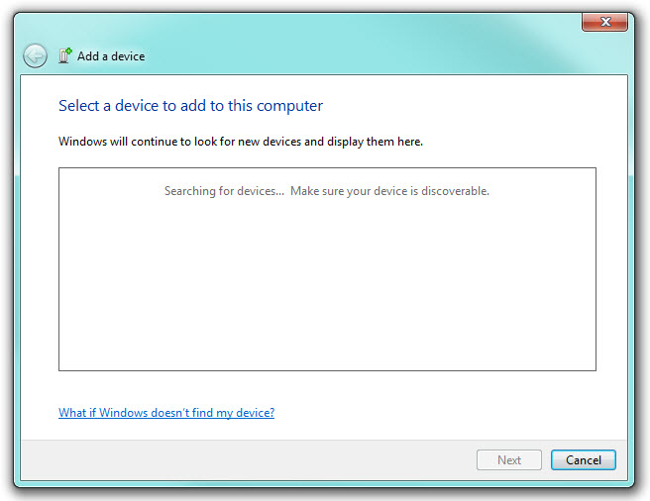
Figure 3.2.6

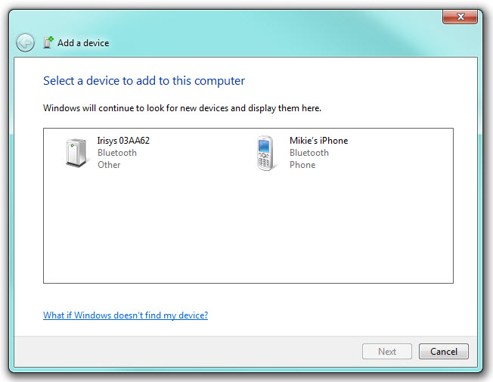
Note that other Bluetooth devices in range of the laptop may also be discovered – this is perfectly normal:
Figure 3.2.7

Step 3
Once your Setup Module has been discovered, click on the entry to highlight it, and then click the ‘Next’ button:
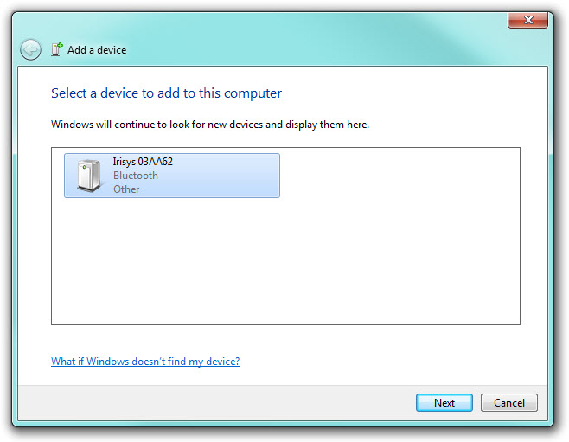
Figure 3.2.8

Windows will connect to the Bluetooth device and after a few seconds, will request a pairing code:
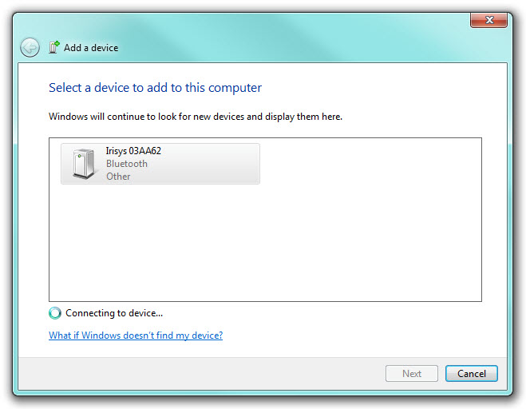
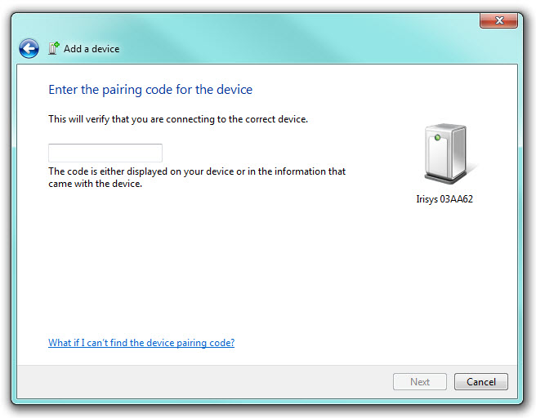
Figure 3.2.9

Enter the code from the bottom of the label on the back of the Setup Module, then click ‘Next’:
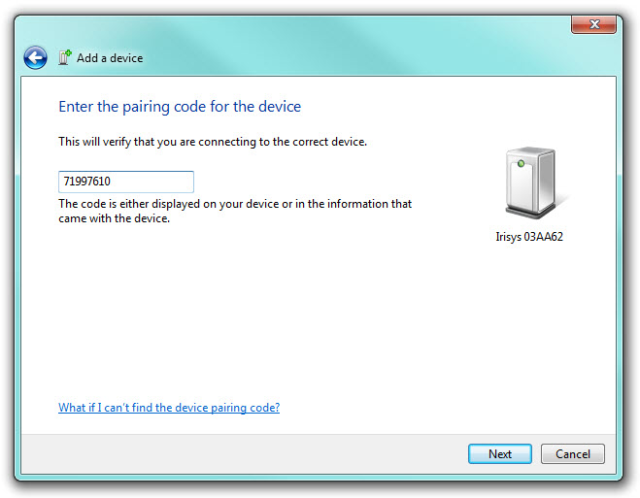
Figure 3.2.10

After a few seconds the new Bluetooth device should be successfully added to your computer:
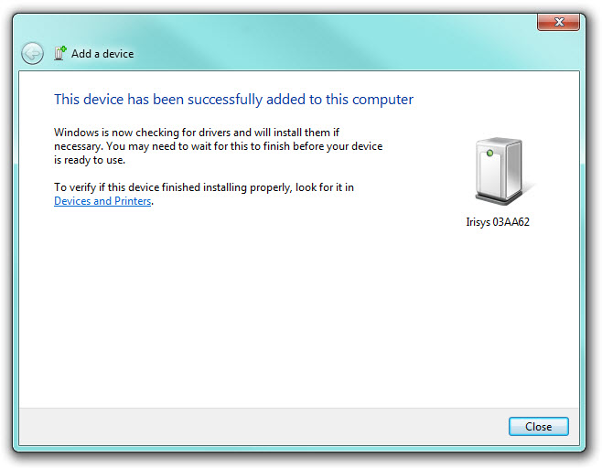
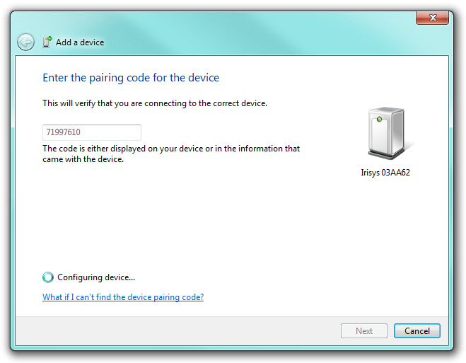
Figure 3.2.11

The Irisys Bluetooth Setup Module will now be shown in the list of paired Bluetooth Devices and/or the ‘Devices and Printers’ window:
Figure 3.2.12

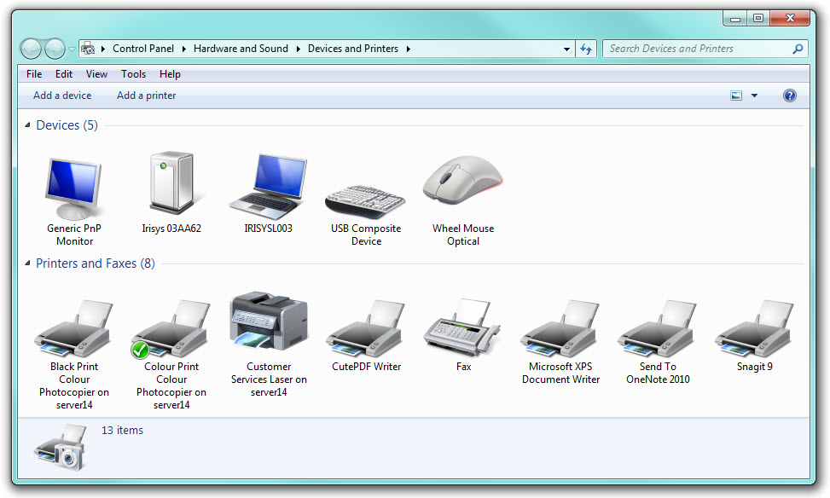
Figure 3.2.13

You should now check the COM port number which has been assigned to the Bluetooth Setup Module for use within PCST.

Errors during the Pairing Process
In some cases the drivers may take a little longer to load and a timer symbol will be shown next to the Bluetooth device:
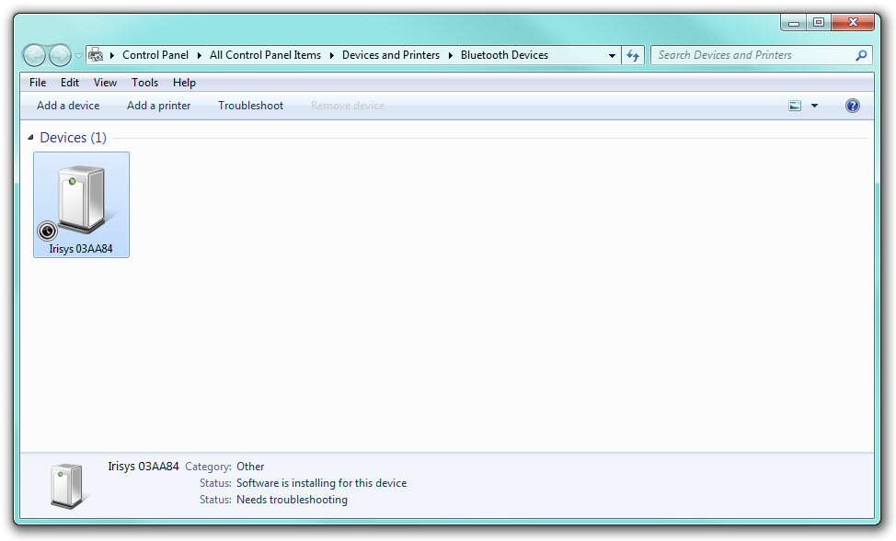
Figure 3.2.14

This is perfectly normal, but on some systems this can take up to 20 seconds to finish. You will not be able to use the Bluetooth device until the drivers have been fully installed.
Once complete the Status will change, and you may also see a notification in the system tray:
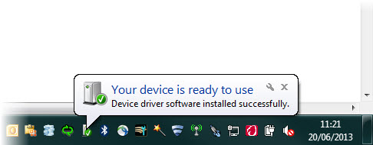
Figure 3.2.15

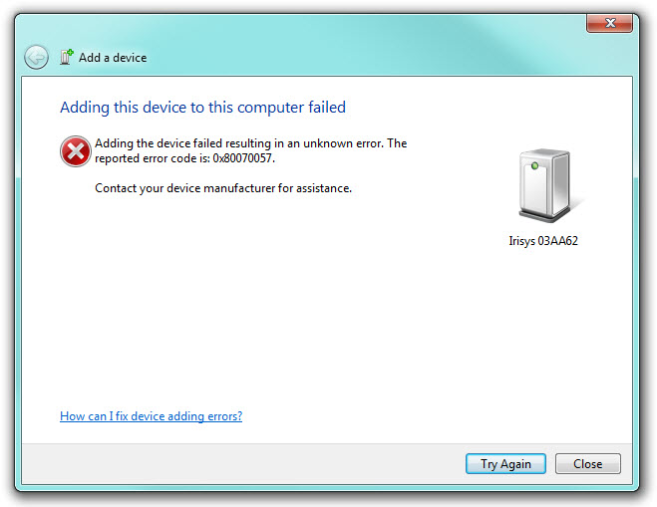
Occasionally the pairing process will fail with an error similar to that shown below:
Figure 3.2.16

If pairing fails, simply click the ‘Try Again’ button and start again from Step 2 in section 3.2.
Note that the pairing process must be completed within a certain period or it will fail. Therefore, once the device has been found and the process begins, you should continue through the process with the minimum of delay in order to avoid seeing this error.

Bluetooth Setup Module Virtual COM Port
Once paired the Bluetooth Setup Module should now be seen as a serial port accessible through the relevant connection option within People Counter Setup Tool (PCST) (see section 4).
If you have other native serial ports on your laptop, or you have ever connected other types of serial adapters to your laptop (USB to serial adapters, PCMCIA serial ports, etc.), it is possible that you will have many COM ports listed as available on your system. It is therefore necessary to know which COM port number is associated with the Bluetooth Setup Module.
To check the COM port number associated with the Setup Module, right click on the Bluetooth Setup Module Device and select the ‘Properties’ option:
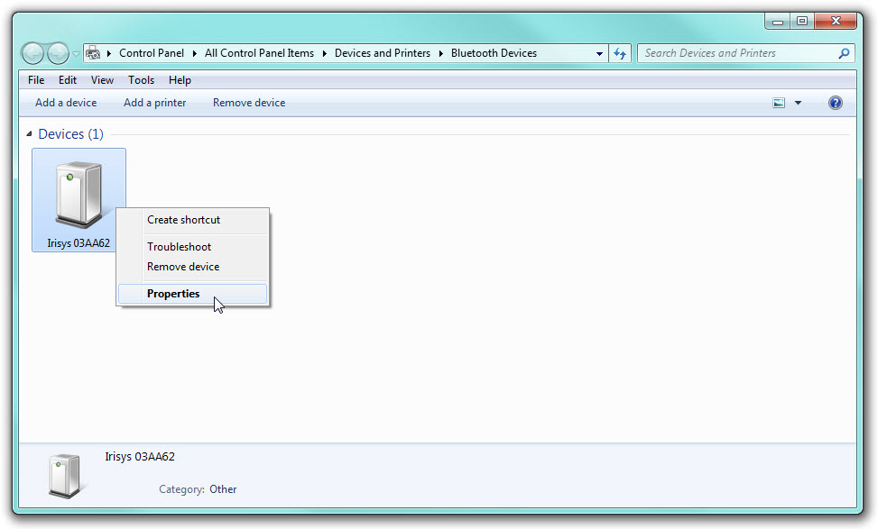
Figure 3.2.17

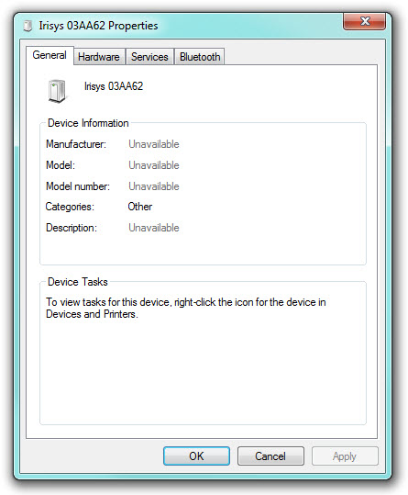
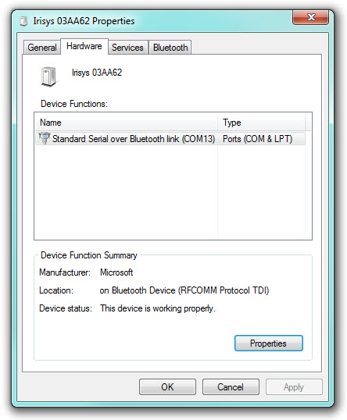
The Properties window for the Bluetooth device will then open. Select the ‘Hardware’ tab and the COM Port number will be listed there:
Figure 3.2.18

You will need to know this COM port number when you attempt to connect to the counter using the People Counter Setup Tool (PCST) software, see next section.

If you look in the Ports section of the ‘Device Manager’ window, you will see that there are actually two COM ports associated with the Irisys Bluetooth Setup Module device:
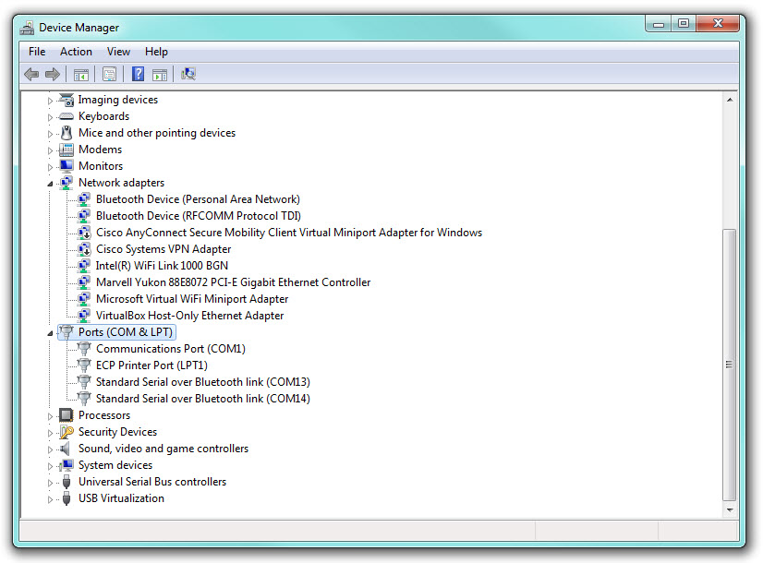
Figure 3.2.19

This is perfectly normal. One COM port is considered the ‘Outgoing Port’ and the other is the ‘Incoming port’.
When connecting to the Bluetooth Setup Module from your laptop you must select the ‘Outgoing’ Port.

Using the People Counter Setup Tool (PCST) Software over Bluetooth
Once a Bluetooth pairing has been made, the counter can then be configured using the Bluetooth connection. Remember that once a Bluetooth pairing has succeeded you still need to be in range of the Bluetooth Setup Module in order to use the connection.
To connect to a counter over Bluetooth connection, firstly ensure that you have the very latest version of the PCST software to ensure full compatibility, and then run it:
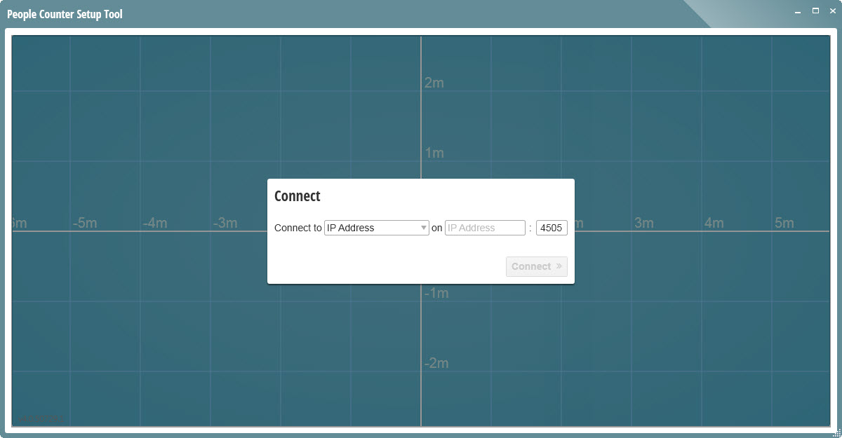
Figure 3.2.1

By default, connection via IP will be selected, so first select ‘Serial’ from the dropdown list on the left and then select the COM port associated with the Bluetooth Setup Module, from the dropdown list on the right:
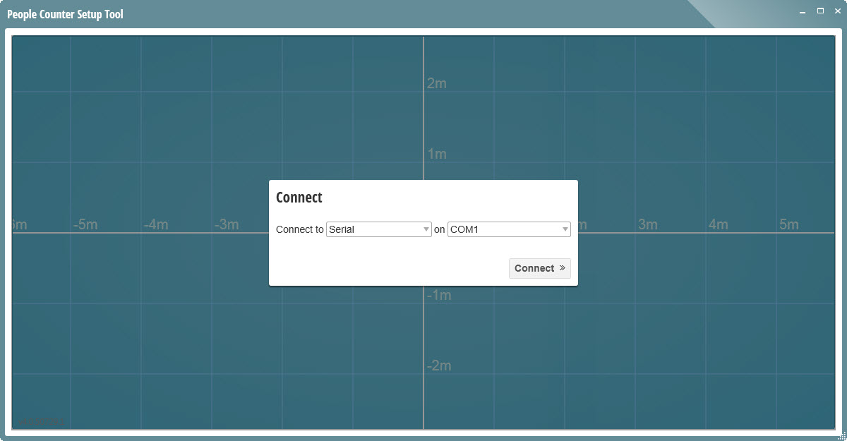
Figure 3.2.2

If you’re not sure which COM port relates to the Bluetooth Setup Module you can check in its Properties, see section 3.2.2.

The PCST software should now connect to the counter and configuration of the counter can be carried out in the normal way.
For details of how to use the PCST software see the separate document, ‘IPU 40521 PCST Software Manual’.

Remember that your laptop must be in range of the Bluetooth Setup Module for a successful connection to be made.

PCST Bluetooth Connection Failures
If PCST fails to establish a Bluetooth connection to the counter, check the following points:
- Has the Bluetooth Setup Module finished pairing with your laptop? If you have just installed the driver, attempting to connect too quickly before the drivers have completely finished installing will fail, see section 3.2.1.
- Have your laptop Bluetooth drivers been installed correctly? Check for errors in ‘Control Panel’, see section 2.2.
- Are you selecting the correct COM port from the drop down list of COM ports available? See section 3.2.2 for how to check the correct COM port number.
- Lastly try moving closer to the counter. If you are out of range of the Bluetooth Setup Module’s signal then a connection will fail.
In all cases, ensure that you are using the very latest version of the PCST (People Counter Setup Tool) Software and try again.

F.A.Q.s
Q. Can the Bluetooth Setup Module be used with any 3000 series unit?
A. Yes, any 3000 series indoor unit can be connected to over Bluetooth using this module. This includes all relay, IP and DualView IP units.

Q. What about outdoor 3000 series units? Can the Bluetooth Setup Module be used with those?
A. No, unfortunately there is no connector available on the outdoor people counters for this adapter to connect to. Even if there was, you would need to mount the Setup Module inside the housing in order to maintain its watertight seal and it would be unlikely for the signal to make it out through the metal casing anyway!

Q. Can the Bluetooth Setup Module be used with any Gazelle series unit?
A. Yes, any Gazelle series indoor unit can be connected to over Bluetooth using this module. This includes all relay, IP and DualView IP units, but remember that you need to remove the break out panel to access the 10 pin connector on Gazelle units.

Q. Can the Bluetooth Setup Module be used with the older 1000 series units, such as the IRC1004?
A. No, although there is a similar connector on the back of the 1000 series units that the Bluetooth Setup Module could potentially plug into, these units are wired differently to 3000 and Gazelle series units and so the Bluetooth module will not work. Do not attempt to use this Bluetooth Setup Module - or any setup module designed to be used with 3000/Gazelle series units - with the older 1000 series units, as damage to the Module and/or the counter may result.

Q. How can I connect to an IP unit over Bluetooth, using my Internet Browser?
A. This is not possible. An internet browser is only for viewing webpages over an IP connection. You can still use the Bluetooth Setup Module with an IP unit, but you must use the installed, exe, version of the people counter setup tool (PCST) software, and choose the serial connection method. See section 4 for how to connect.

Q. I am using the Bluetooth Setup Module to connect to an IP enabled 3000 series unit, but how do I configure the Client connection settings/DNS settings/etc.?
A. Connecting via Bluetooth Setup Module is the same as connecting via a cabled serial connection and similarly, these settings are not accessible. To configure those details you must connect via IP through an internet browser or set them via the API functions using your own software.

Q. I want to use the Bluetooth Module to retrieve count data from the unit, how can I do this?
A. The Bluetooth Setup Module is for configuring the counter only; it cannot be used to retrieve count data from a counter.

Q. How do I transmit the relay pulses via Bluetooth?
A. Again, this is not possible. The Bluetooth Setup Module is for configuring the counter only; it cannot be used to retrieve count data from any counter variant - relay or IP.

Q. I have changed the IP address of an IP enabled unit and now can’t remember what it is. Can I use the Bluetooth Setup Module connection to fix this?
A. Yes, as with the serial setup cable, you can connect to the counter using the Bluetooth Setup Module with the installed version of the PCST software in order to locate the IP address and set it to the required address. This also allows you to reset the login password if required.

Q. My laptop doesn’t have Bluetooth; can I still use the Irisys Bluetooth Setup Module?
A. Yes, but you will need to buy a third party USB Bluetooth adapter to connect to your laptop. Once installed and configured, you will then be able to connect to the Irisys Bluetooth Module.
Q. My laptop has Bluetooth, but I’m not sure how to activate it, what should I do?
A. Every laptop is different. Look for a switch or a button with the Bluetooth logo on it, or possibly a system tray icon, which can be used to enable Bluetooth (see section 2.3). If in doubt, consult your laptop instructions or the manufacturer’s website.

Q. My laptop has Bluetooth, but the drivers don’t seem to be installed properly. Can you send me the drivers?
A. Every laptop is different, so if you need drivers for your laptop, you will need to search through the support section of your laptop manufacturer’s website for Bluetooth driver downloads.

Q. My laptop has some yellow exclamation marks next to some of the devices in the Device Manager window (see section 2.2), how do I fix this?
A. Again, every laptop is different, but generally you should right click on the device and select the Update Driver option. Windows may locate the drivers from the Internet automatically for you but you may still need to obtain the correct drivers from the laptop manufacturer’s website first.

Q. My Bluetooth Setup Module has stopped working on my IP counter, and so too has the standard serial cable (IWC3062) connection. Is the counter faulty?
A. It’s unlikely that something has failed but remember that you can’t use the Bluetooth Setup Module and a serial cable at the same time. If you want to use the Bluetooth Setup Module, you must disconnect the Serial Setup cable; and if you want to use the Serial Setup Cable, you must disconnect the Bluetooth Setup Module.

Appendix A - The Pairing Process on Windows XP
With Windows XP the pairing process is a little different.
Locate your Bluetooth devices dialog and click the ‘Add…’ button to start the ‘Add Bluetooth Device Wizard’:
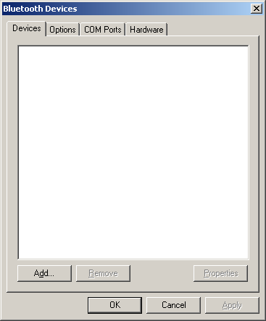
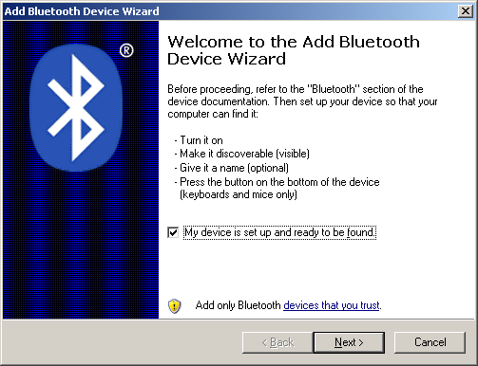

Ensure the Irisys Bluetooth adapter is connected to the counter and that the counter is powered. Then place a tick in the ‘My device is set up and ready to be found’ check box, and click ‘Next’.
The wizard should find the Irisys Bluetooth Setup Module (plus potentially other Bluetooth devices). Highlight the correct device and click the ‘Next’ button (remember that the last six characters on the label relate to the label on the front of the Bluetooth module itself):
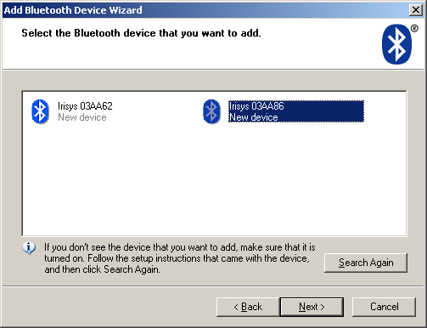

On the next screen select the ‘Use the passcode…’ option and enter the code from the label on the back of the Irisys Bluetooth adapter, then click ‘Next’:
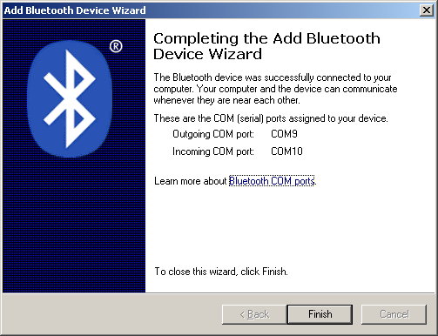
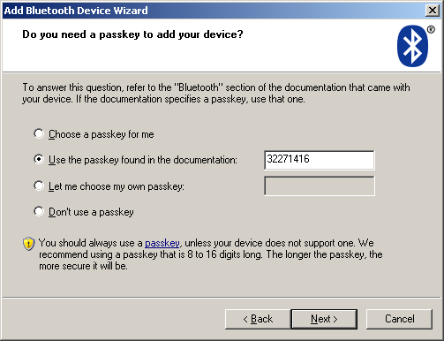

Once the Add Bluetooth Device Wizard is complete make a note of the Outgoing COM Port assigned to the device, and then click ‘Finish’.

The Irisys Bluetooth Setup Module will now be shown in the ‘Bluetooth Devices’ Window. To check that the driver has been installed correctly, click the ‘COM Ports’ tab and ensure that there are two COM port numbers listed for the device. One will be listed as ‘Incoming’ and one as ‘Outgoing’:
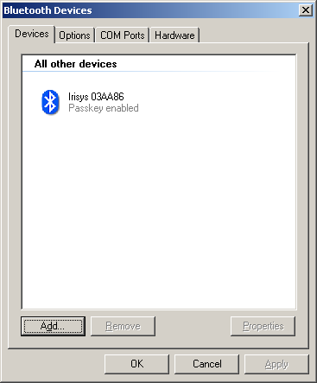
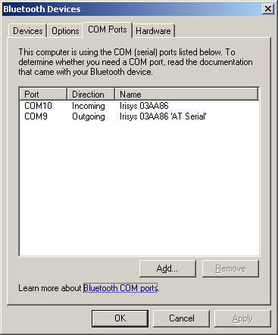

The ‘Outgoing’ COM port number is the one that you must use to connect to the counter within the PCST software.

Appendix B - Breaking a Bluetooth Bond
If you would like to remove a Bluetooth device from your list of paired devices, this is very easy to do.
Firstly, go to your list of Bluetooth devices:
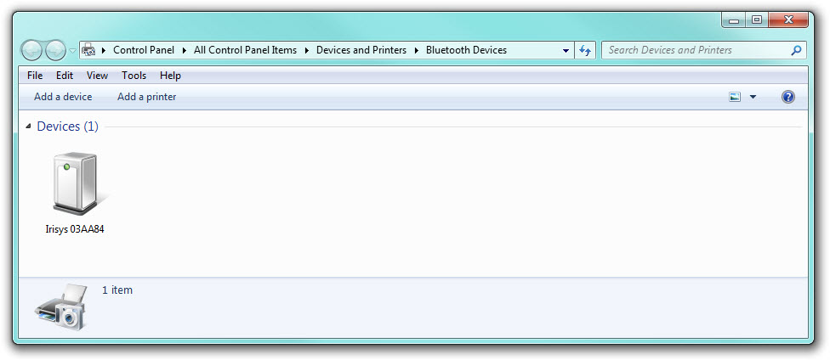

Now right click on the device that you would like to remove, and select the ‘Remove Device’ menu option:
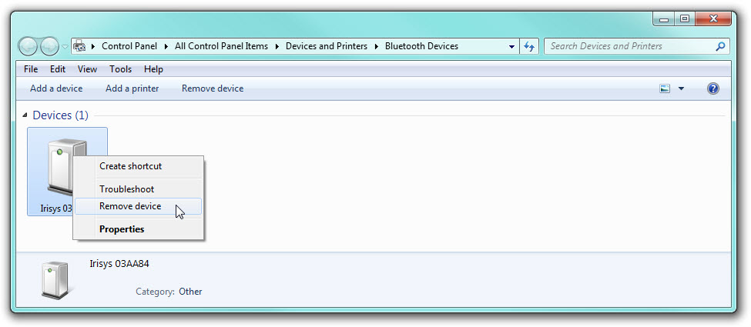

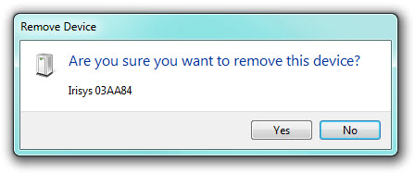
Confirm the warning message and the bond between the Bluetooth device and your laptop will be broken:

If you later want to use a particular Bluetooth device again, you will need to go through the pairing process again, as if a brand new device, before you can use it. See section 3.2.

