Accessing the Valve Manifold
01 Feb 2022
M. Daniels

Overview of the sequence: This document is specific to the access and inspection of the “B3-VT” vent valve, but it can also be applied to any of the larger “B” style valves used on the 6270A.

Remove electrical and pneumatic power from the 6270A.
Remove the top cover.
Remove the electrical module from the chassis:
- A screw on the left and right sides
- disconnect four electrical connections – three wire harness connectors and a USB connection
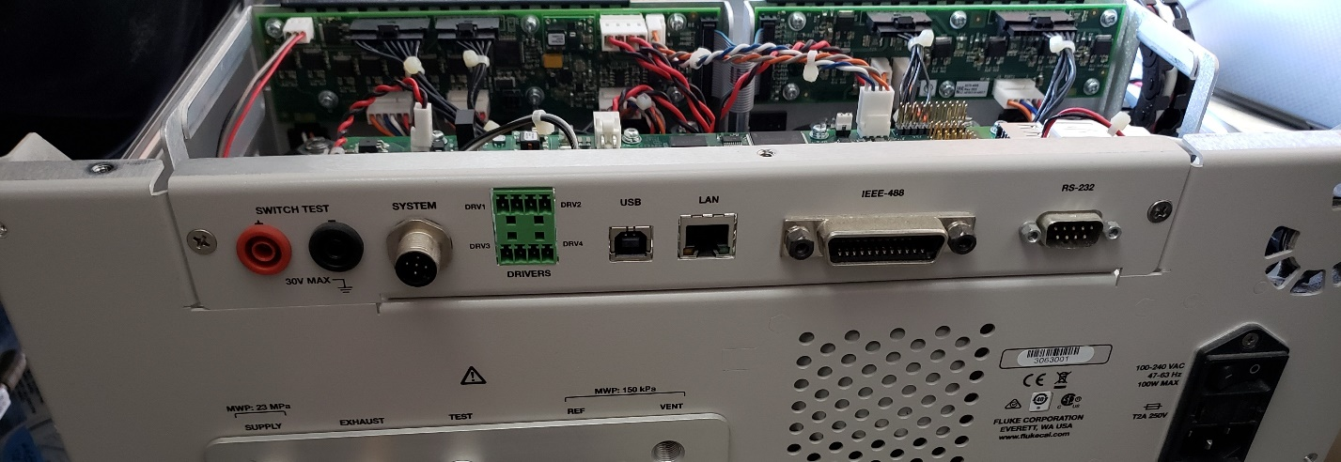

Locate the B3-VT valve, remove the coil pack.
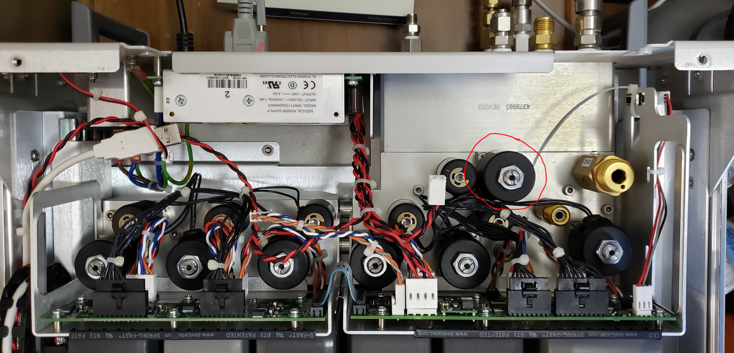

Unscrew the valve body from the valve base:
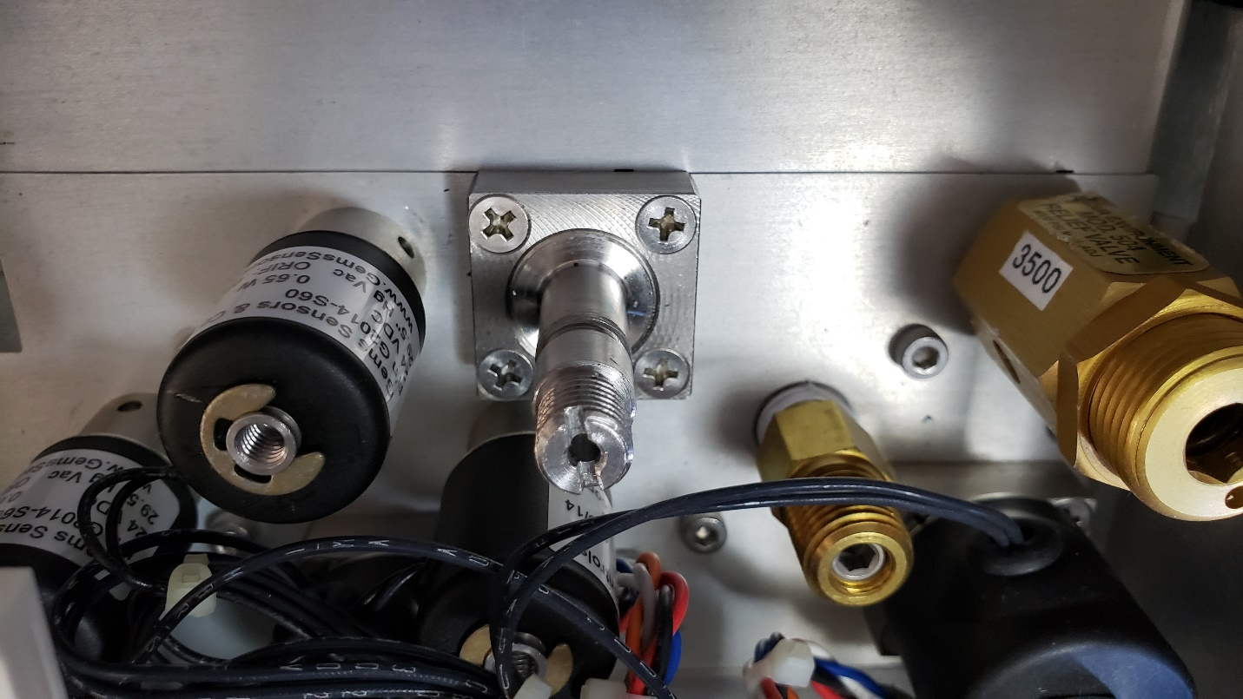

Inspect the valve seat (blue material) and the valve base for contamination. Clean if necessary. Note: this photo shows a good valve seat which is free of contamination and a typical dimple on the face of the seat.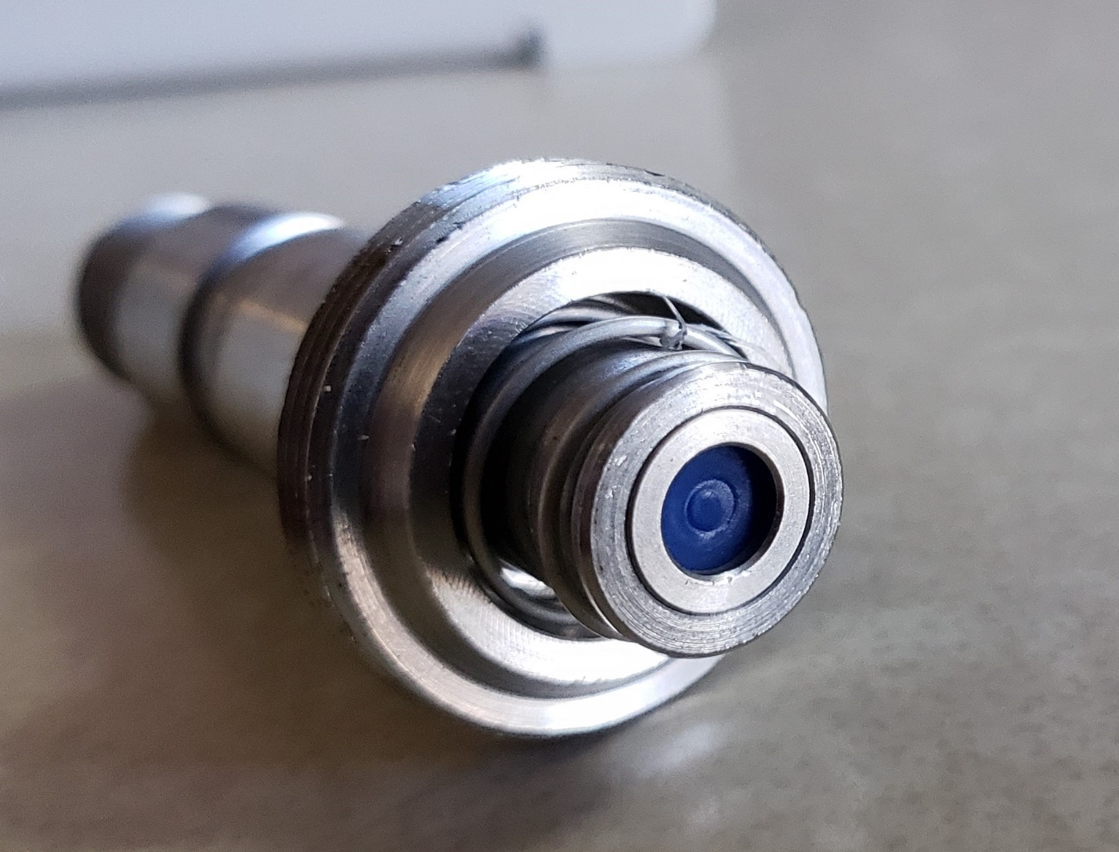

Ensure the o-ring in the valve base is present and in one piece:
