Use a PM200/600-Axxx as Source for Barometric Pressure
14 February 2017
M. Daniels

An absolute style pressure module can be used as the source for barometric pressure when using a 6270A. The rules of the 6270A limit the selection to either an A100K or BA100K pressure module. These modules can be configured as the barometric pressure source from the front panel of the 6270A. The same modules can also be called from COMPASS.

Using an AutoDetect setup for the 6270A, the selection “6270 Ambient Pressure” can be assigned as the source for Ambient Pressure. Internal to the 6270A, this selection will use what has been configured by the user under the menu <SETUP | MEASURE SETUP | ATMOSPHERE ➔ Module Selection>. For example, if “Manual Entry” has been selected, then COMPASS will use the user-define value provided to the 6270A. On the other hand, for example, if “Slot 2: 15 psia” has been selected, then COMPASS will receive a real-time update of barometric pressure as provided by the A100K pressure module in slot #2.

Barometric Source Selection for an AutoDetect 6270A:
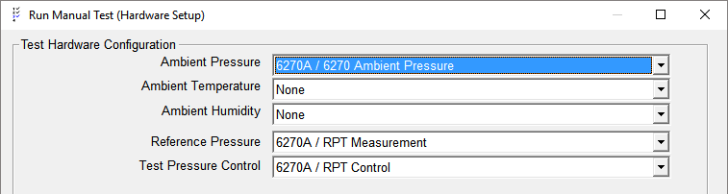

For situations where either you have an absolute style PMM which is not an A100K or you want the confidence that COMPASS will always use a known source for barometric pressure, then you can create a support device which will read directly from the PMM.

The approach is to create a COMPASS Support Device that directly queries the pressure module for a value. This approach is not dependent upon the front panel configuration of the 6270A, and it is not limited to only the A100K or BA100K modules. Any absolute style PMM can be used for the source of Ambient Pressure. It can provide the user confidence that the desired pressure module is the source for ambient barometric pressure.

Barometric Source Selection for a macro-driven 6270A Support Device:
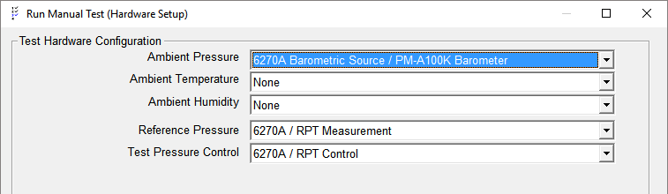

The Support Device definition is setup to work with the PMM in any user-define slot in the 6270A chassis. The slot number is populated on the Calibration tab under the “Calibration Setting4” field.

No AutoDetect Setup, and Serial Number field is populated with the PPM s/n.
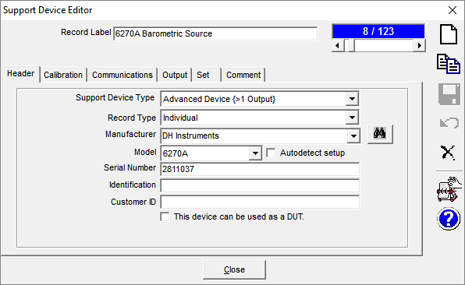

On the Calibration tab, the slot number for the PMM must be specified. Slot #1 is on the left side of the chassis ending with #5 on the right side.
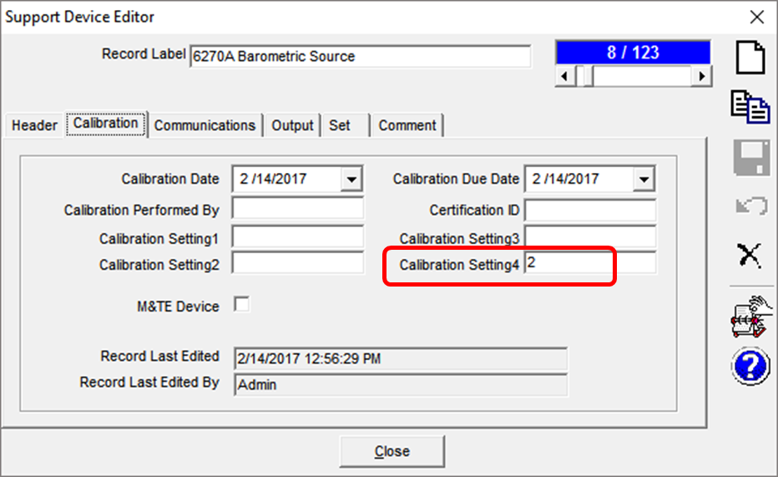
Use the same Communications selections as the primary 6270A Support Device
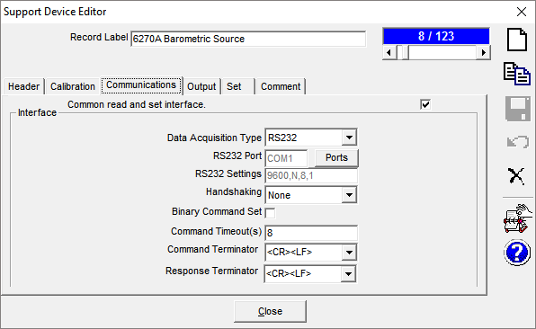

Use the “Add” button to create a new Output. Configure the Raw and Final output parameters using the “Edit Output” button. Tip: Use of the Label field can help identify the source when running a COMPASS test.
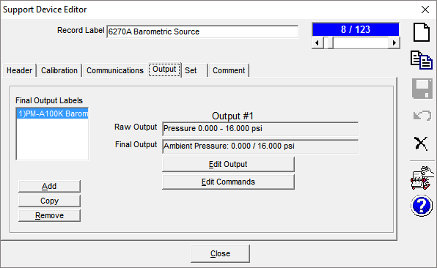
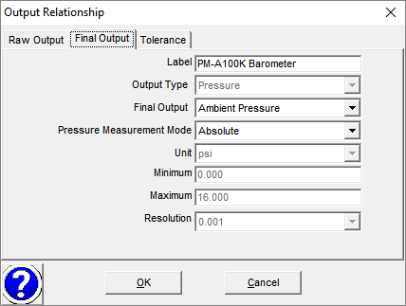

Edit Commands: The command type is “Read” and Command line is a macro driven function. If the macro has not yet been created, then from the Command line drop down menu, scroll to the bottom of the list and select the “[Add/Edit Macro]” option. This will open the COMPASS Macro Editor tool, where the macro can be created. Macro code is provided at the end of this tutorial.
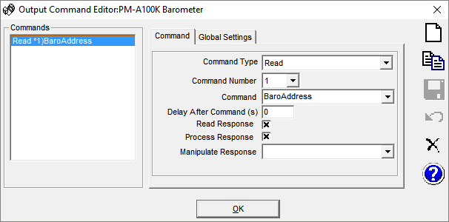

There are no Set commands or configurations to be made. The Comments can be useful for the operator(s).
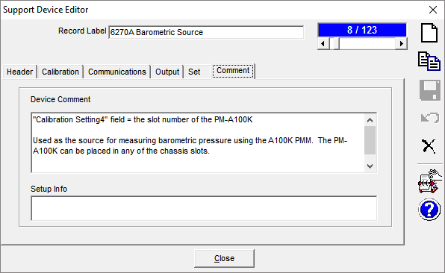

COMPASS Macro Editor: A “GetCommand” macro is required for interpreting the slot number into the remote command to query the PMM.
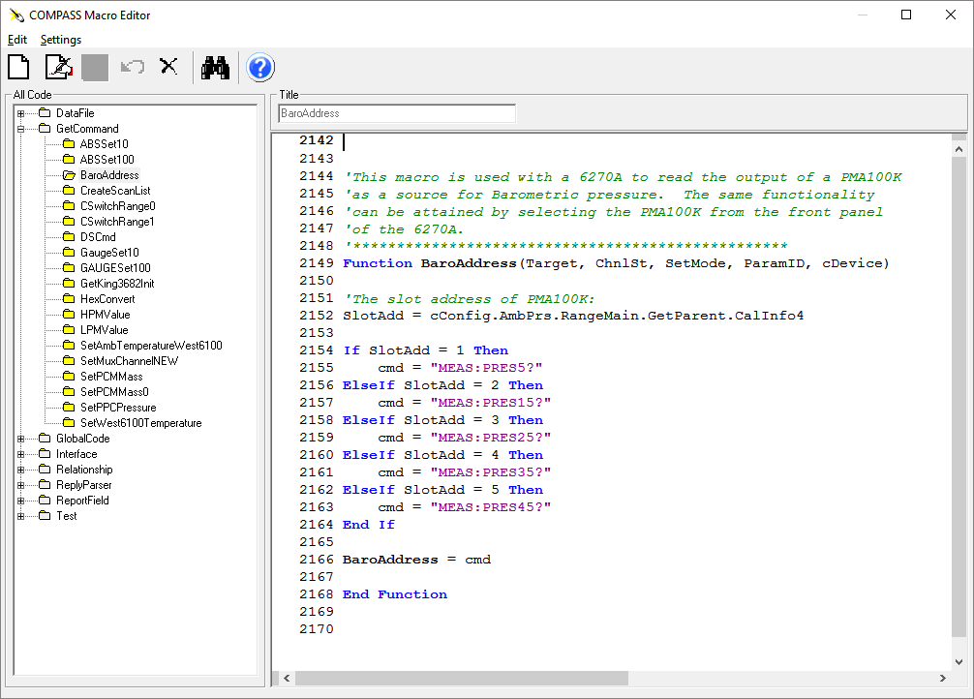

Code:
'This macro is used with a 6270A to read the output of a PMA100K
'as a source for Barometric pressure. The same functionality
'can be attained by selecting the PMA100K from the front panel
'of the 6270A.
'**************************************************
Function BaroAddress(Target, ChnlSt, SetMode, ParamID, cDevice)

'The slot address of PMA100K:
SlotAdd = cConfig.AmbPrs.RangeMain.GetParent.CalInfo4

If SlotAdd = 1 Then
cmd = "MEAS:PRES5?"
ElseIf SlotAdd = 2 Then
cmd = "MEAS:PRES15?"
ElseIf SlotAdd = 3 Then
cmd = "MEAS:PRES25?"
ElseIf SlotAdd = 4 Then
cmd = "MEAS:PRES35?"
ElseIf SlotAdd = 5 Then
cmd = "MEAS:PRES45?"
End If

BaroAddress = cmd

End Function

