Fluke 2638A Multiplexer Setup Using its Internal DMM to Read Volts
This is from the Sample/Example 2638A Support Device that is already in the COMPASS for Pressure (v5.0.50 and higher) new install database as an example. If you don’t already see this in your database as a Support Device then you can get it from the hidden example database. See the COMPASS help file for instructions on how to search for, and use, example setups. Also this web page, COMPASS Example Database
This example only shows the voltage output setup but the other outputs; amps, frequency and ohms are setup in the same way.
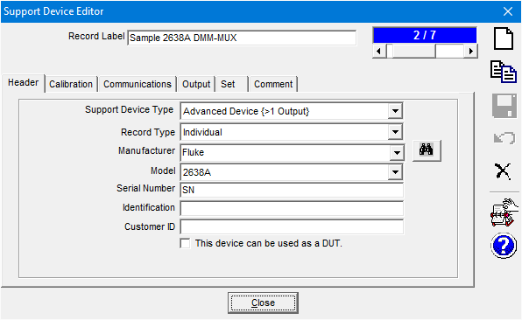
The information on the Calibration tab is optional.
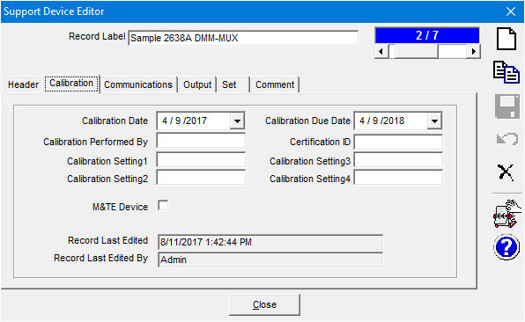
In the 2638A Support Device setup, go to the Communications Tab. Here is a view for RS232 setup using the USB output on the 2638A. Note that the Command Terminator can be set to CR or CR LF by remote commands to the 2638A. If the replies are on the same line, or the next line (erroneously) check this setting in the 2638A.
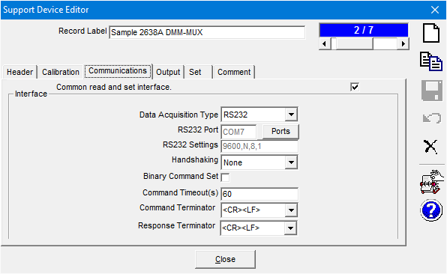

Go to the Output Tab and select the Voltage ScanList output
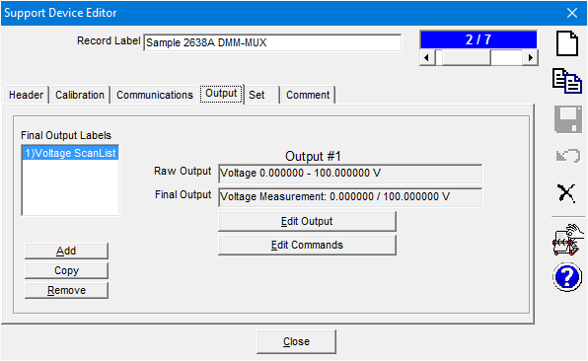

Output Tab, [Edit Output] Button, Raw Output
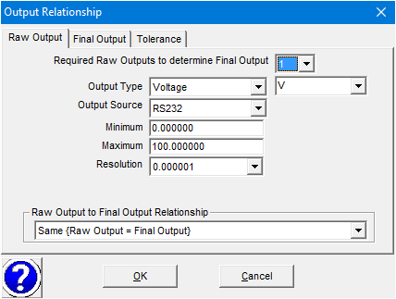
Output Tab, [Edit Output] Button, Final Output
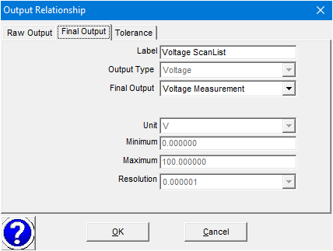

Output Tab, [Edit Commands] Button
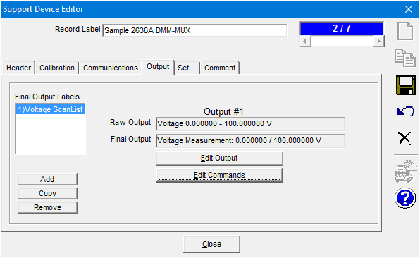
Output Tab, [Edit Commands] Button, Read Command. Should look like this.
A ReplyParser macro named "ParseScanListRead" is used to parse the comma-separated reply that is received from the 2638A. If you don't have this macro in the drop-down list, see the macro text at the end of this document to copy and paste it into a new macro in the COMPASS Macro Editor. The COMPASS Macro Editor can be opened directly from the Command drop-down list [Add/Edit Macro] selection, or from the Tools menu when COMPASS is idle.
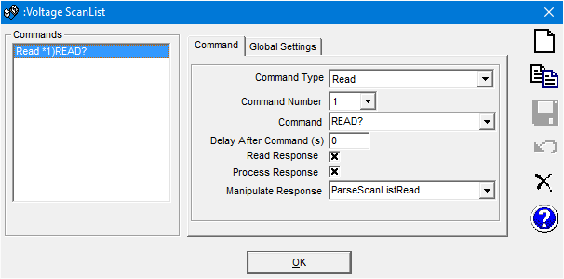
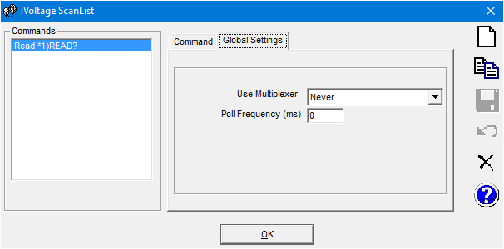

Save any changes by pressing the disk icon, then press the [OK] button to close this window.
Go to the Set Tab, select the “MUX Ch ScanList” output then click the [Edit Set] Button.
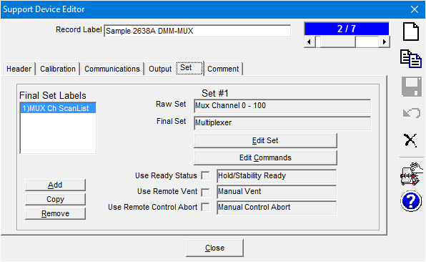

Set Tab, [Edit Set] Button, Raw Set
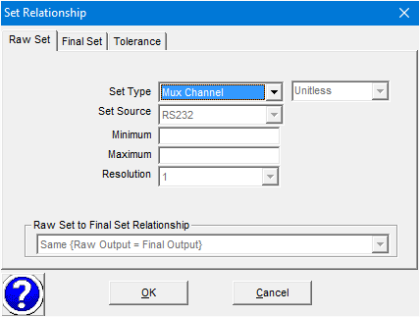
Set Tab, [Edit Set] Button, Final Set
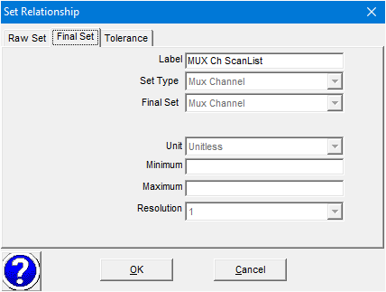

Set Tab, [Edit Commands] Button
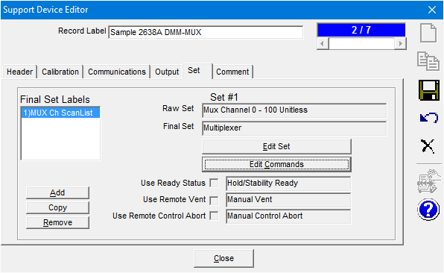
Set Tab, [Edit Commands] Button, Initialize Command, for MUX Ch ScanList. A GetCommand macro named "CreateScanList2638A" is used to create the command that will be sent to the 2638A to set the active channels. If you don't have this macro in the drop-down list, see the macro text at the end of this document to copy and paste it into a new macro in the COMPASS Macro Editor. The COMPASS Macro Editor can be opened directly from the Command drop-down list [Add/Edit Macro] selection, or from the Tools menu when COMPASS is idle.
The rate is set to fast with the RATE FAST command (change if desired, see the 2638A Programmer's guide for more information).
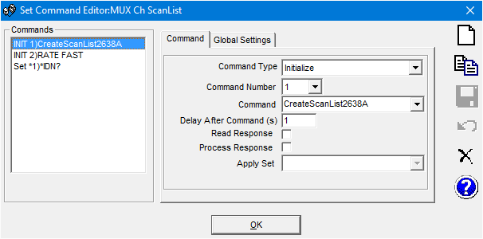
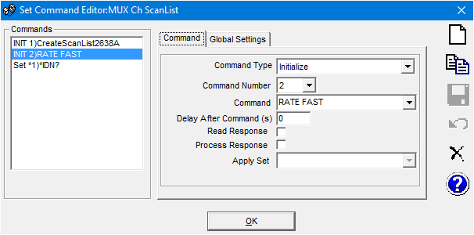
Set Tab, [Edit Commands] Button, Set Command. COMPASS needs a reply to we just use the *IDN? command. The reply is not used for anything.
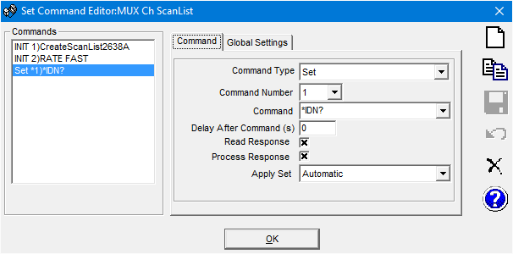
Save any changes by pressing the disk icon, then press the [OK] button to close this window.

Comments tab, all comments are optional. Setup Info section is shown during test initialization.
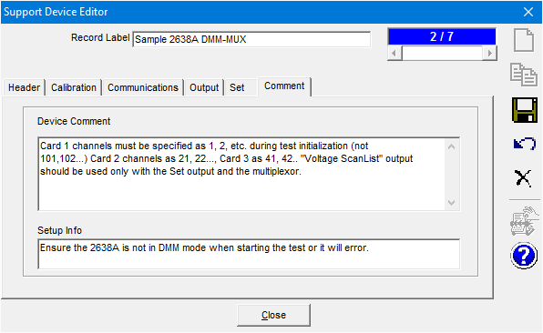

Now run a manual test to check if it’s working by this menu path;. [Run],<Run Manual Test>.
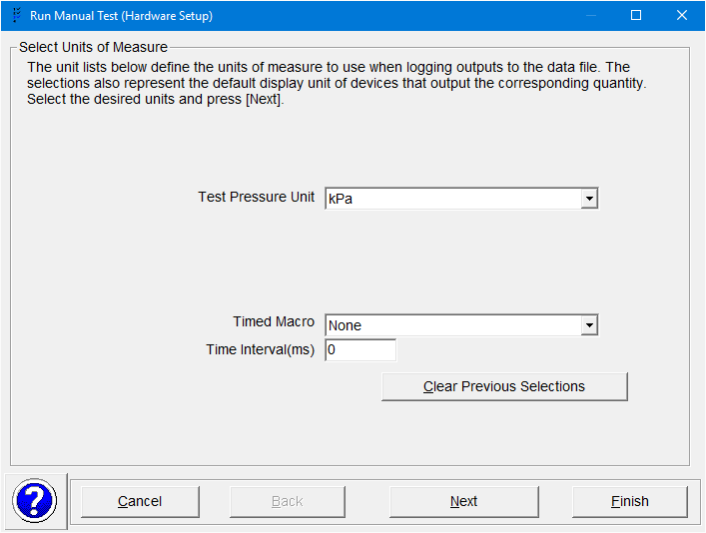
Ten identical DUTs are chosen for this example. Choose more than one of the same DUT by double-clicking it again. COMPASS will ask you how many of them you want in the test.
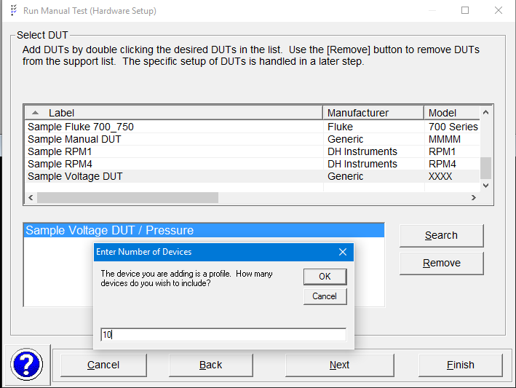

Enter the serial number, check the "Use Multiplexor" box, then enter the multiplexer channel in the “Channel” box. The CreateScanList2638A will automatically change a channel entered as 1 to 20 into 101 to 120 (card 1), and from 21 to 40 into 201 to 220 (card 2), and 41 to 60 into 301 to 320 (card 3). The channel will automatically increment for any more DUTs. Edit as necessary. Choose the 2638A output as the Voltage(V) device at the bottom left.
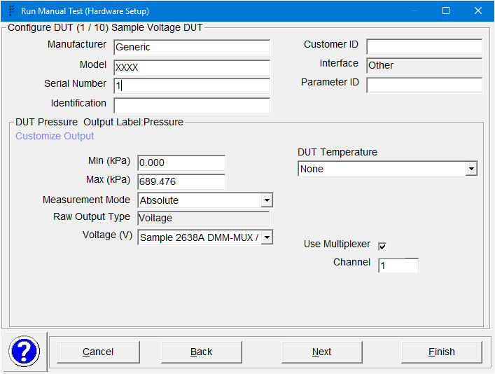

DUT 2
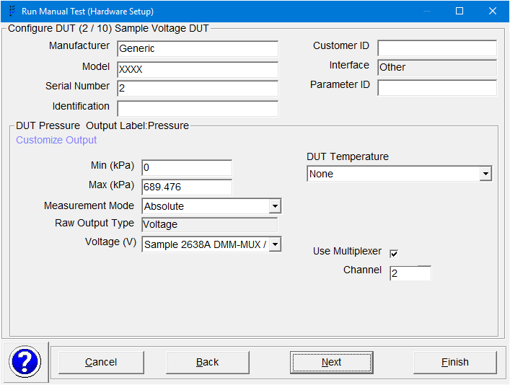

For the multiplexer choose the 2638A output labeled “MUX Ch ScanList”. Choose a Reference Pressure and Test Pressure Control devices if you want to.
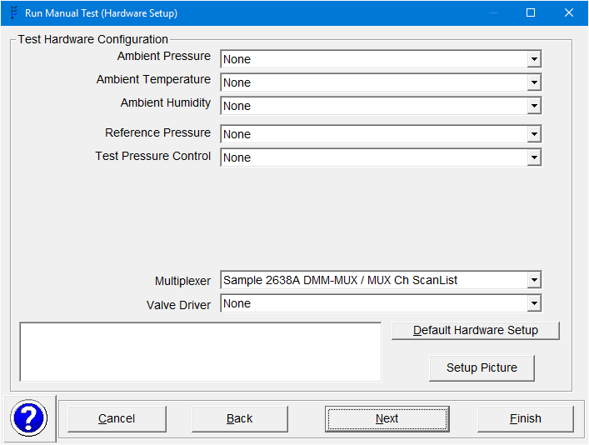

The setup and macros work for Auxiliary devices also.
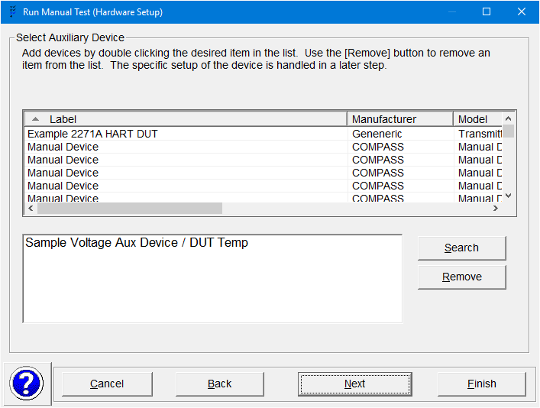

The screen for the 2638A shows that it has two outputs; a read output “Voltage Scan List” and a set output “MUX Ch ScanList”
Slider to left
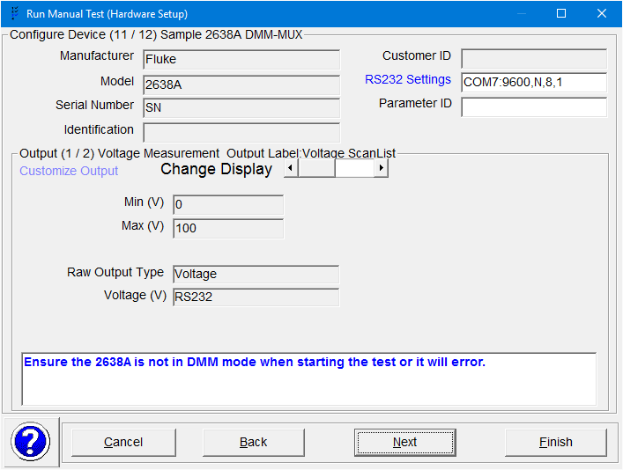

Slider to right
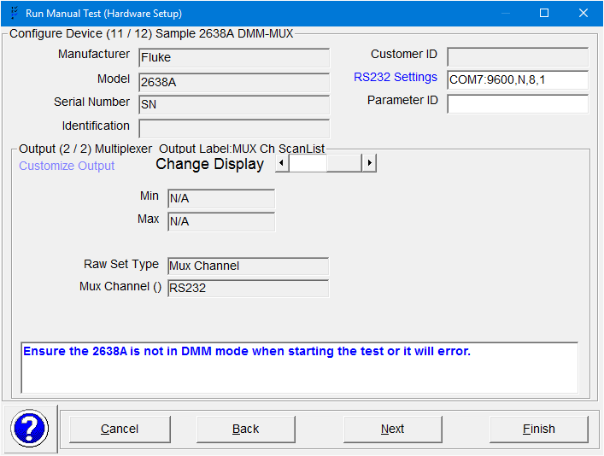

If you chose an Auxiliary device its setup screen appears next. It's on channel 18 (118) in this example.
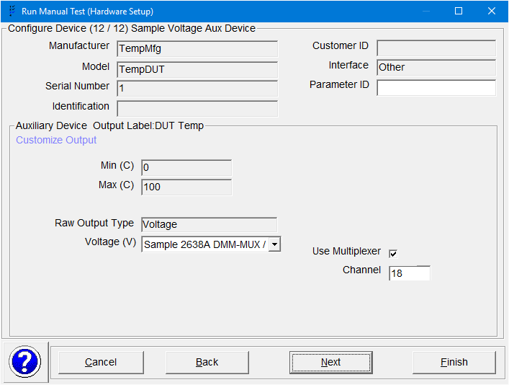

The final verification screen. Make sure the 2638A is not in DMM mode when pressing the [Finish] button or it will error and not work.
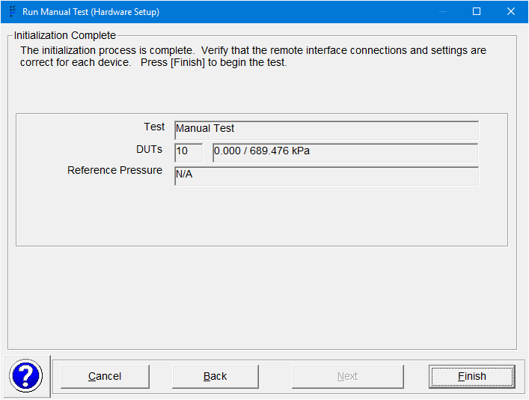

Here is the COMPASS Run Window
The interface spy is shown to the right of the 2638A's window. Display it by clicking on the yellow value for an output (like Voltage ScanList) and selecting “Display Interface Spy” from the drop-down list. More details on this here, Display Interface Spy in COMPASS for Pressure
Note that the 2638A is switching from channel 1 to 10 (and 18 for the Aux device), and the voltage is being read for each channel appropriately.
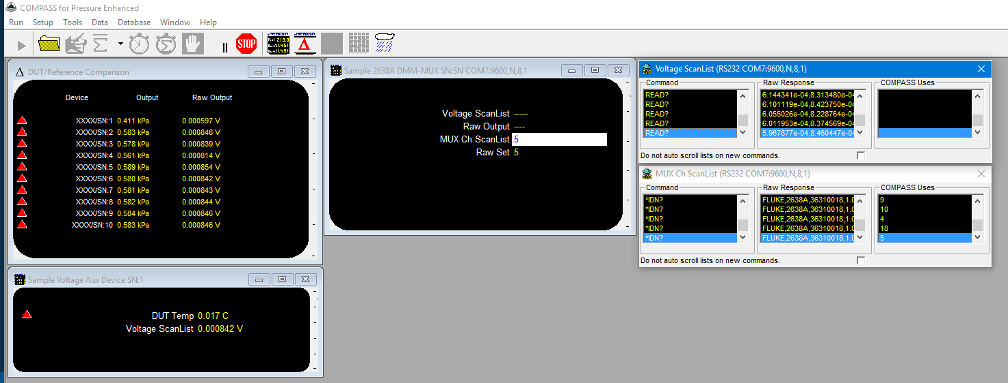

This is the ReplyParser macro “ParseScanListRead”. Add it as a new ReplyParser macro by copying the text below and pasting into a new ReplyParser macro. Use CTRL+V to paste in the COMPASS Report Editor. It also uses GlobalCode macros “GetNumericValue” and “ExtractText” that are included with the default COMPASS database CompSetp.mdb. This macro works for the 2638A and the Agilent/Keysight 34970A.

'****************************************
'This Function must return the fully formatted response
'of a device. The output is used as the Raw output
'in the relationship determination of the Final Output.
'
'Reply :Raw unmanipulated response of a device.
'ParamID :Parameter ID of the device
'cRange :Device Range class that the output applies to.
'
'The value is returned by setting the function name =
'to the calculated value.
'
'For example: ReplyParser33361 = val(mid(rawReply,5))
'****************************************
Function ParseScanListRead(Reply, ParamID, cRange)

'When a HP34970A is used to scan multiple channels
'at the same time, it responds with all data collected
'from a simple Read? command. Look at the CreateScanList
'GetCommand MACRO.
'With this setup, parse the responses into the varios
'raw outputs of the devices but DO NOT RETURN
'a value for the function. The Raw Output Update
'will update the output of each device automatically.

inc = -1
With cCOMPASS.cConfig
for i = 1 to .DUTPrs.Count
chnl = .dutPrs(i).RangeMain.MuxChannel
if chnl > 0 and chnl <=60 then
'The device is setup to use a MUX,
'So give it it's Raw Output
inc = inc + 1 'Step to the next position in the response
temp = qextract(reply,inc, inc+1,",") 'Get an individual value
.dutPrs(i).RangeMain.RawOutput = GetVal(temp)
end if
next

'Get any auxiliary mux scan info as well..
for i = 1 to .Auxiliary.Count
chnl = .Auxiliary(i).RangeMain.MuxChannel

if chnl > 0 and chnl <=60 then
'The device is setup to use a MUX,
'So give it it's Raw Output
inc = inc + 1 'Step to the next position in the response
temp = qextract(reply,inc, inc+1,",") 'Get an individual value
.Auxiliary(i).RangeMain.RawOutput = GetVal(temp)
end if
next

End With
'Never Respond, We already updated the data
ParseScanListRead = ""

End Function

This is the GetCommand macro “CreateScanList2638A”. Add it as a new GetCommand macro by copying the text below and pasting into a new GetCommand macro. Use CTRL+V to paste in the COMPASS Report Editor.

'****************************************
'This Function must return the command to be sent to a remote device
'to obtain the desired output.
'
'Target :Target value when the SetMode it True (Valve Driver Chnl).
'ChnlSt :True/False to activate or de-active a valve driver.
'SetMode :True for Set commands, False for all other commands.
'ParamID :Parameter ID of the device
'cDevice :Device class that the relation ship applies to.
'
'The value is returned by setting the function name =
'to the calculated value..
'
'For example: GetCommand30460 = val(mid(rawReply,5))
'****************************************
Function CreateScanList2638A(Target, ChnlSt, SetMode, ParamID, cDevice)

'Create the Voltage Output Scan List based on the DUTs and AUX
'devices currently selected... When the scan list is sent
'1 time to the 2638A, a simple READ? returns the
'Complete array of scanned data,

With cCOMPASS.cConfig
For i = 1 To .DUTPrs.Count
chnl = .dutPrs(i).RangeMain.MuxChannel

If chnl > 0 And chnl <=60 Then
'The device is setup to use a MUX, so make it happen...
If cmd = "" Then
cmd = GetChannelID(chnl)
Else
cmd = cmd & "," & GetChannelID(chnl)
End If
End If
Next

'Get any auxiliary mux scan info as well
For i = 1 To .Auxiliary.Count
chnl = .Auxiliary(i).RangeMain.MuxChannel

If chnl > 0 And chnl <=60 Then
'The device is setup to use a MUX, so make it happen...
If cmd ="" Then
cmd = GetChannelID(chnl)
Else
cmd = cmd & "," & GetChannelID(chnl)
End If
End If
Next

End With

'If there is Scan List INFO, then make it happen
If cmd <> "" Then
CreateScanList2638A = "CONF:VOLT:DC (@" & cmd & ")"
End If

End Function

'********************************************
'Return the fully qualified channel
'ID assument that channels are in order
'from 1 to 60 corresponding to
'
'1-20 BANK 1 channels 1-20
'21-40 BANK 2 channels 1-20
'41-60 BANK 3 channels 1-20
'
'********************************************
Function GetChannelID(chnl)

If chnl>= 1 And chnl< 21 Then
'BANK 1 chnl 1- 20
tBase = chnl
BANK = "1"

ElseIf chnl>=21 And chnl< 41 Then
'BANK2 channel 1 - 20
tBase = chnl-20
BANK = "2"

ElseIf chnl>=41 And chnl< 61 Then
'BANK3
tBase = chnl - 40
BANK = "3"

Else
'This is some type of an error
Exit Function
End If

'Must be a 3 digit value 101, not 11
If tbase < 10 Then
GetChannelID= BANK & "0" & tBase
Else
GetChannelID= BANK & tBase
End If

End Function

