**Flow Training Class Station 1 COMPASS for Flow Setup**

**DUT Setup - 200 sccm hydrogen MFC, calibrate in nitrogen. K-factor =1.024**

**Setup as Advanced DUT to use DUT as flow control device in COMPASS for Flow.**

**UNIT INSTRUMENTS (A) ufc-1660 is already in Process Gas Edit and has K-factor of 1.024.**

Must enter at least one; SN, ID or Customer ID

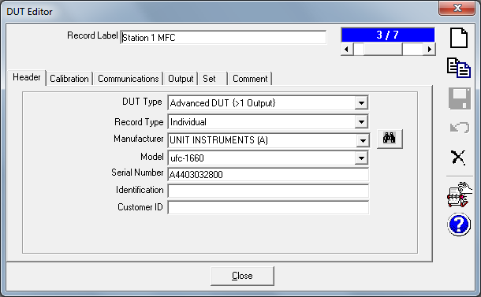

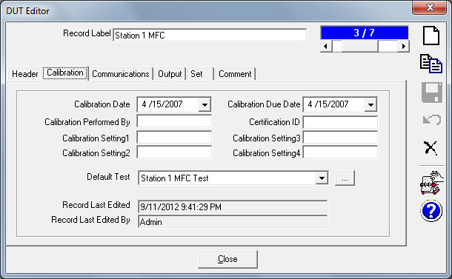

Will read MFC’s voltage output through MFC circuit of molbox1+ (not in the drop-down list so choose “Other Device”). Will specify device when initializing test.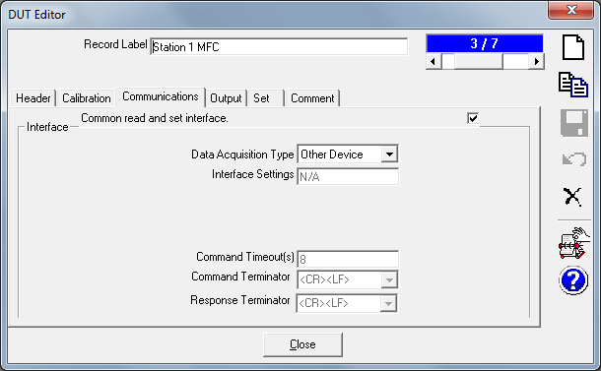

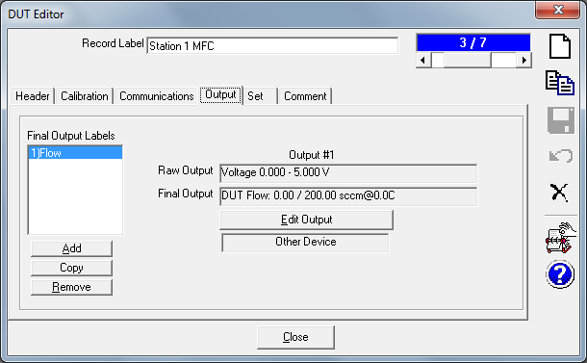

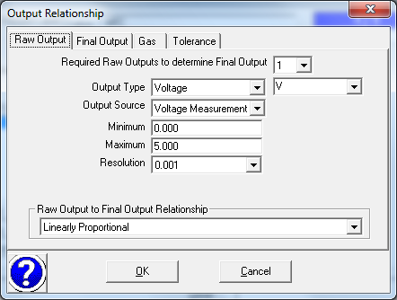

“Label” can be anything you want.

Could have chosen “Never” in “Use Multiplexor” drop-down.

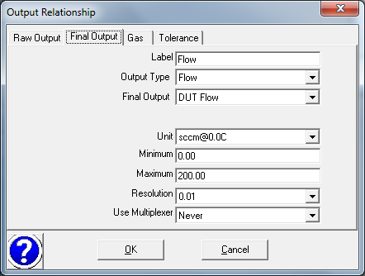

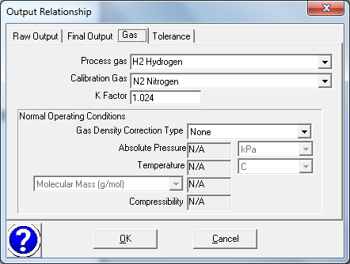

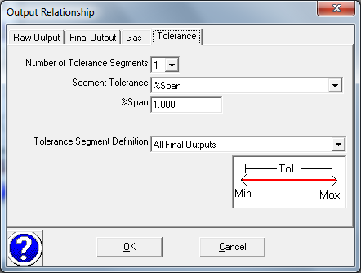

**Set** Tab (Set is also commonly called “control”)

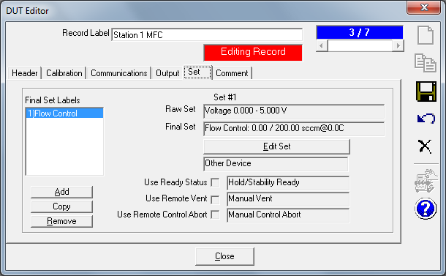

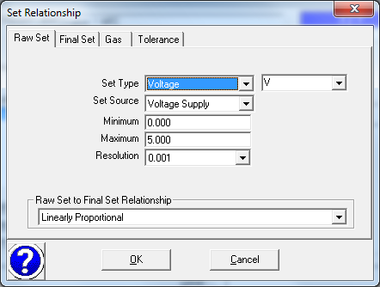

“Label” can be anything you want.

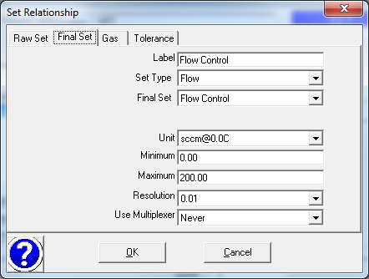

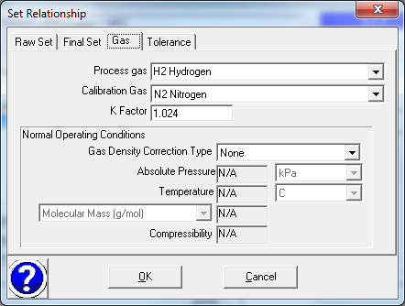

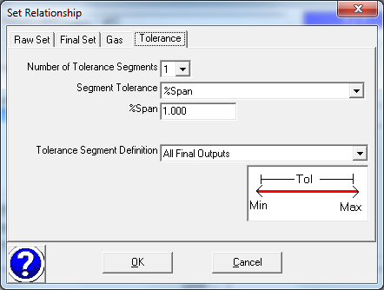

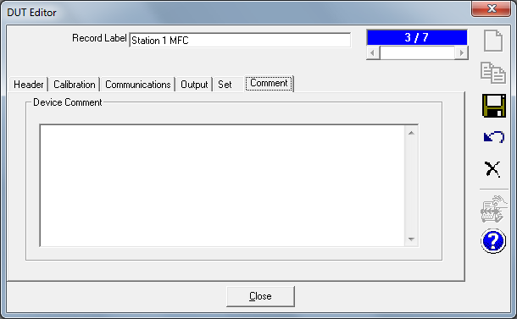

**Flow Training Class Station 1 COMPASS for Flow Setup**

**Test Setup for 200 sccm MFC**

Will do any leak testing and purging before running the COMPASS test.

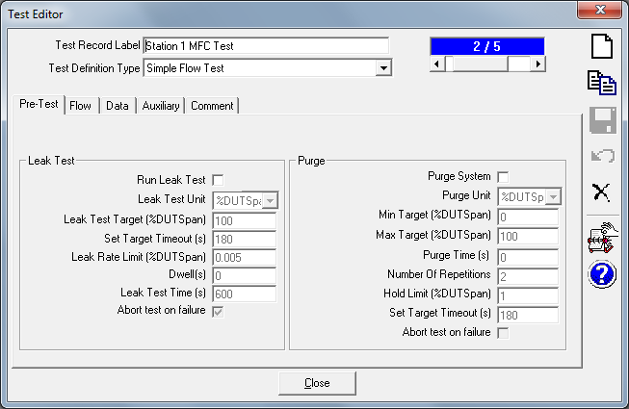

Read = Reference, Set = Controller

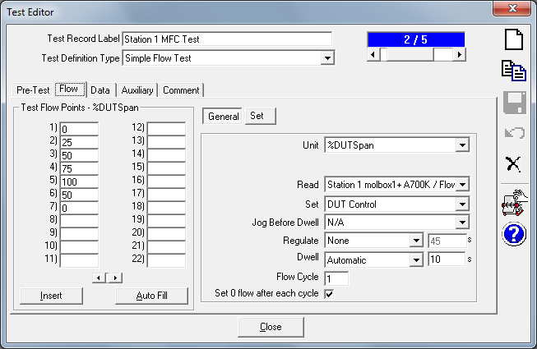

Control mode doesn’t matter for flow tests. Can choose any of the options in drop-down list.

If hold limit or stability limits are set to zero they are ignored. Check settings in [Tools], <Options>, <Run Test> tab also.

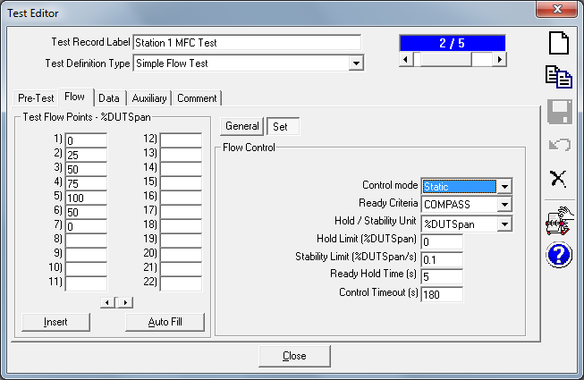

When ”Default” is chosen in a drop-down list the devices in [Setup], <Default Hardware Configuration> are used during Test Initialization – But can be changed during Test Initialization also if desired.

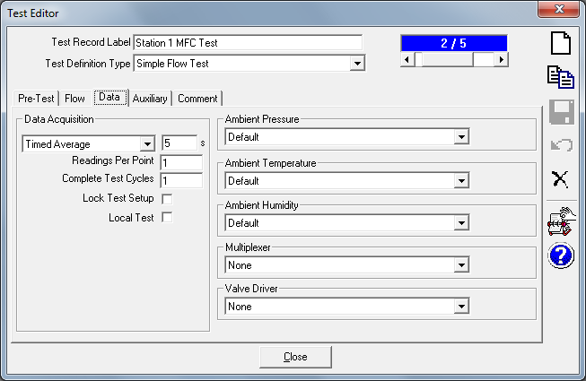

No auxiliary devices used in this test

