Replacing the Main Printed Circuit Board
15 August 2022
M. Daniels

Scope: replace the main PCB with p/n 4815126 – “SERVICE PCA, CHASSIS, PROCESSOR / COMMUNICATIONS - WITH SOFTWARE”. This board is shipped preprogrammed with software and is a drop-in replacement for use with the 6270A. The calibration of the Pressure Measurement Modules is not affected by board replacement as the calibration data for the PMMs is stored locally with each module.

Remove electrical and pneumatic power from the 6270A.
Remove the top cover.
Detach the electrical module from the chassis – a single screw on the left and right sides:
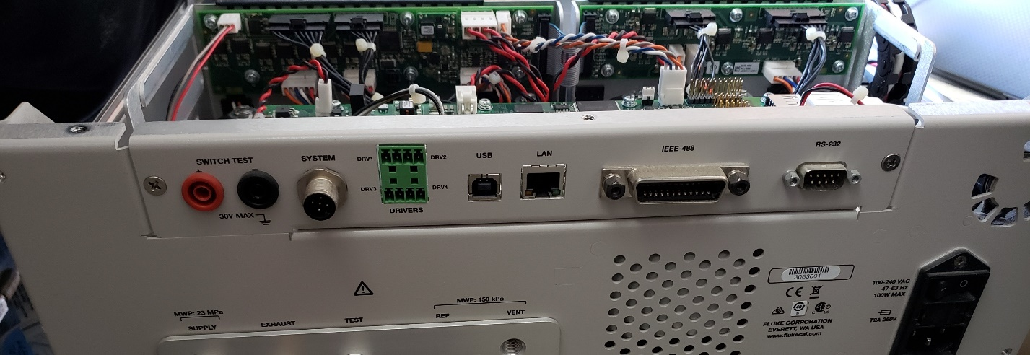

Disconnect the six wire harness connectors:
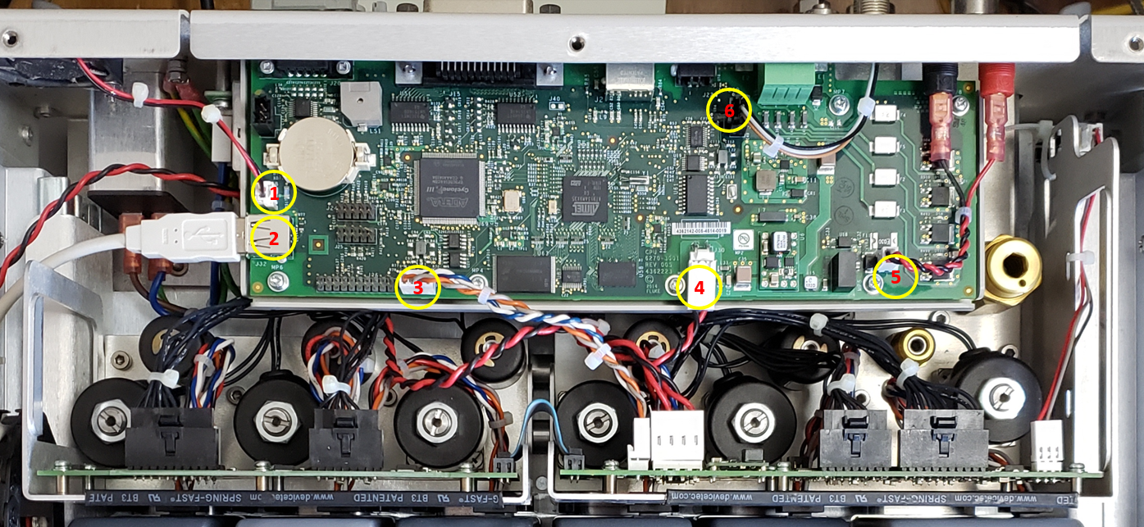

Remove the retaining screws for the IEEE-488 and RS-232 ports:
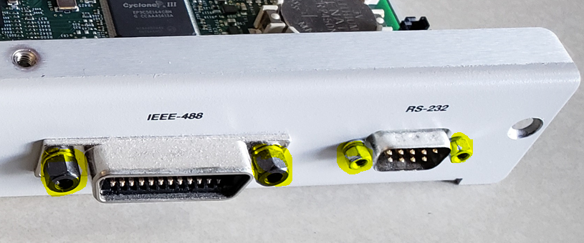

Remove the six screws which secure the board to the electrical module sheet metal:
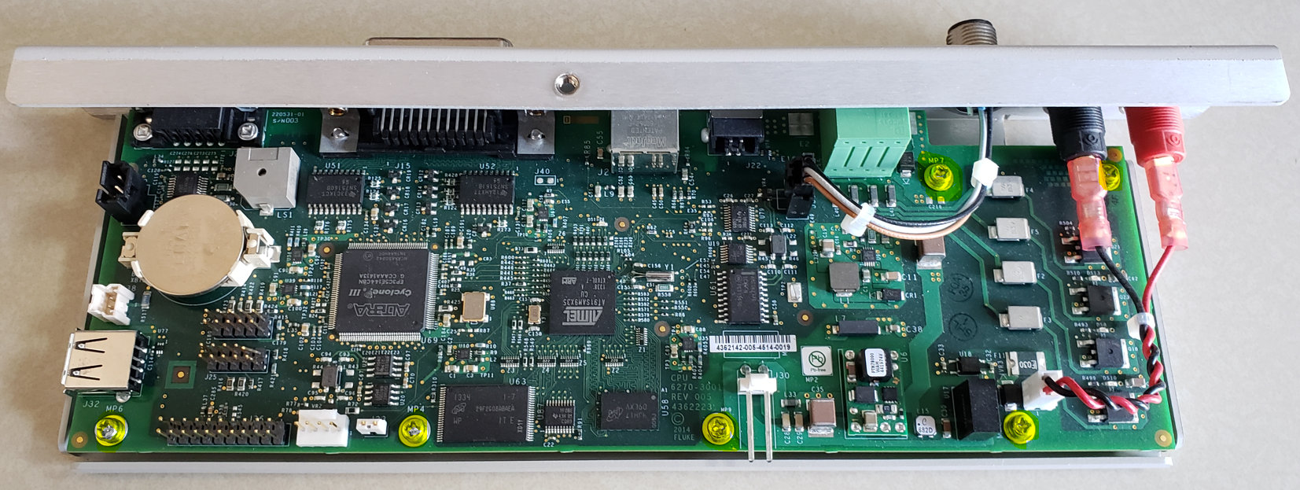

Install the new board, reassemble in reverse order.

