**PPC4 Firmware Upgrade Tutorial**

May 2016

M. Daniels

Updated: 23 Oct 2020

This tutorial walks the user through the process of updating the embedded firmware of the PPC4. The firmware file has a “.bin” extension. It is written to the PPC4 using the “WinFlash.exe” application. The PPC4’s RS232 COM1 port is the interface used to perform the update.

Equipment required:

* RS232 cable, 9 pin, D-sub connectors, male – female pins, straight through wiring
* PPC4 binary file (“PPC4 v1_2_6_14.bin”). Available for download:

<https://us.flukecal.com/literature/software-downloads/firmware/ppc4-embedded-software>

* Winflash.exe Available for download at flukecal.com: <http://us.flukecal.com/literature/software-downloads/free-utilities/winflash-free-utility>
* Winflash.setup file. Available for download at Fluke Corporation Zendesk:

<https://flukecorporation.zendesk.com/hc/en-us/articles/208725626-PPC4-Winflash-Setup-file>

Software:

* Download and install the free WinFlash utility @ Flukecal.com – need to sign in or register for access to the download.
* Download and save the Winflash.setup file. The setup file must be saved to the root WinFlash directory which is typically “C:\Program Files (x86)\WinFlash”.
* Verify which COM port will be used on the computer. For example, if the computer has a hard-wired RS232 port, it is typically mapped by Windows® as “COM1”.

Procedure:

1. Power on the PPC4.
2. Connect 9-pin RS232 cable between the computer and the PPC4.
3. Verify and record the current version of firmware – press and hold the [ESC] key.

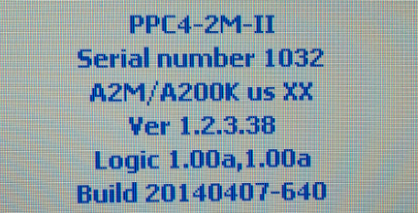

1. Run Winflash.exe.
2. Select the RS232 option

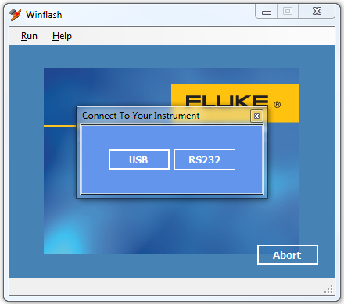

1. From the [Run] menu, select “Product”, “Released”,”PPC4”

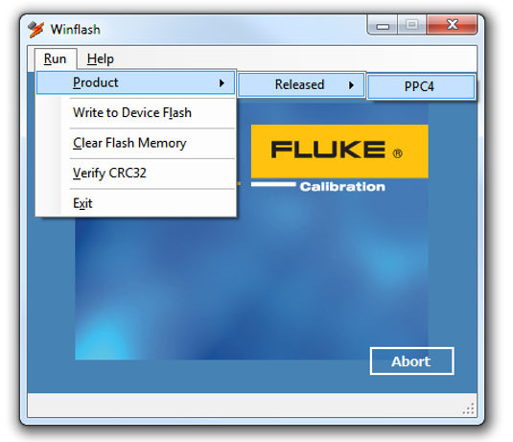

1. Select the COM port of the computer which has the RS232 cable connected to it. Press Ok to continue.

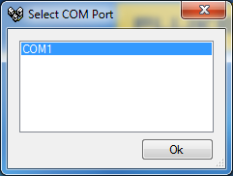

1. Turn off the power to the PPC4, then click OK to continue. Turn the PPC4 power back on after the OK is clicked.

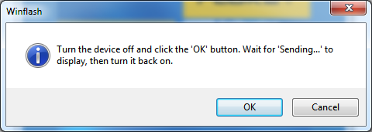

The PPC4 display will change to the FLASH LOAD MODE message when the flash interface has been successfully initiated.



1. Next, WinFlash begins to erase the existing flash data in the PPC4 in preparation to write the new.

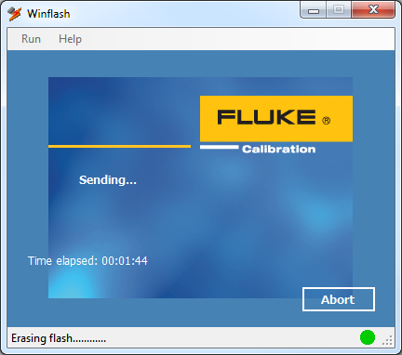

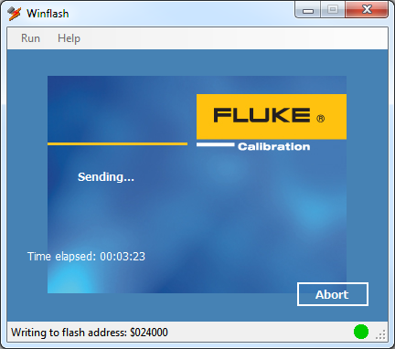

1. When the process is complete, a verification window will appear. An upgrade confirmation screen appears on the PPC4 with the default answer of “Yes” highlighted with a black background. Press the PPC4 [ENTER] key to confirm.

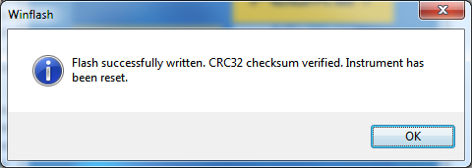

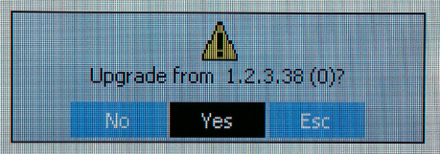

1. Press and hold the ESC key to verify the new firmware has been applied.

