4322 Firmware Tutorial: Update to v1.4.4.3
August 2019
M. Daniels

This tutorial walks the user through the process of updating the embedded firmware of the 4322 to v1.4.4.3 The firmware file has a “.bin” extension. It is written to the 4322 using the “WinFlash.exe” application. The 9-pin RS232 port is the interface used to perform the update.

Version 1.4.4.3 Removes the BaroCheck process and related menus from the 4322, and it provides modified testing points for the A150K alignment process. The points are 5, 10 15, 20, 15, 10, 5 psia.

Equipment required:
- RS232 cable, 9 pin, D-sub connectors, male – female pins, straight through wiring
- 4322 binary file (“4322 v1-4-4-3.bin”)
- Winflash.exe
- Winflash.setup file

Software:
- Install the WinFlash utility which is appropriate for your computer. A 32-bit and 64-bit version are provided.

NOTE: must choose the "Custom" installation option and deselect the PPC4 USB Driver
option. Not doing this results in an error: “-1603 Fatal Error During Installation” .

- Copy the “Winflash.setup” file to the root WinFlash directory which is typically “C:\Program Files (x86)\WinFlash”.
- Copy the 4322 binary file to the same root directory – typically, “C:\Program Files (x86)\WinFlash”.
- Verify which COM port will be used on the computer. For example, if the computer has a hard-wired RS232 port, it is typically mapped by Windows® as “COM1”. A USB-RS232 adaptor is typically mapped to a different COM port.

Procedure:
- Power on the 4322 Controller.
- Connect 9-pin RS232 cable between the computer and the 4322.
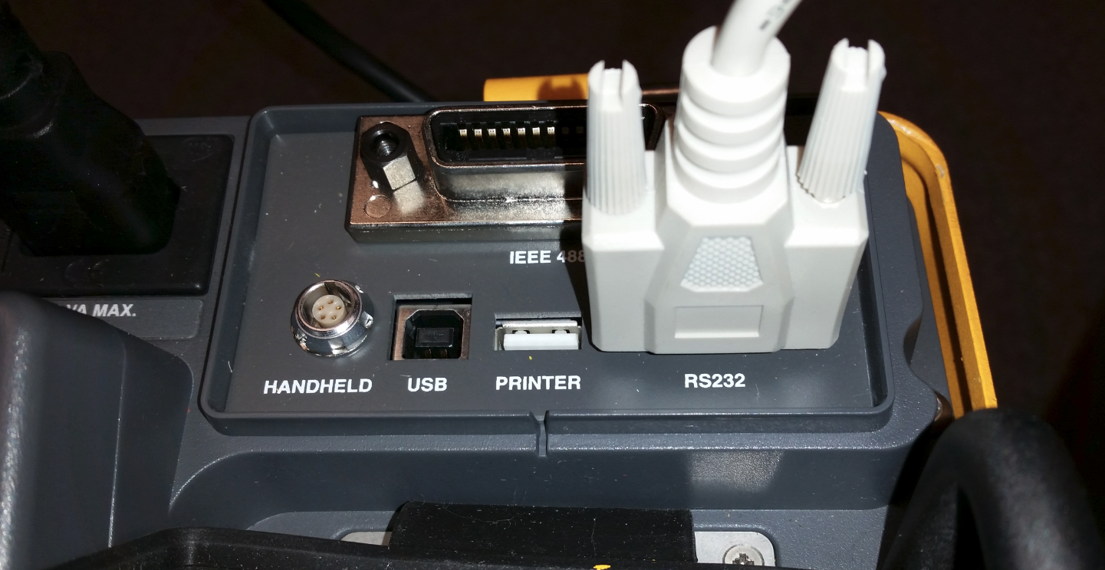
- Verify and record the current version of firmware – press and hold the [ESC] key.
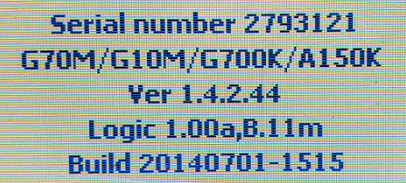

- Run Winflash.exe
- Select the RS232 option
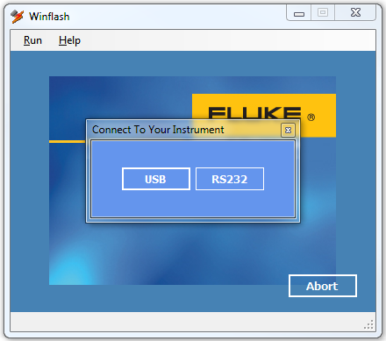
- From the [Run] menu, select Product -> Released -> 4322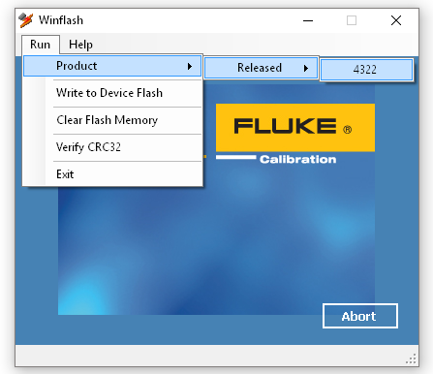

- Select the COM port of the computer which has the RS232 cable connected to it. Press Ok to continue.
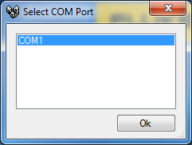
- Turn off the power to the 4322, then click OK to continue. Turn the 4322 power back on after the OK is clicked.
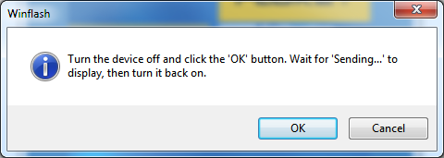
The 4322 display will change to the FLASH LOAD MODE message when the flash interface has been successfully initiated.
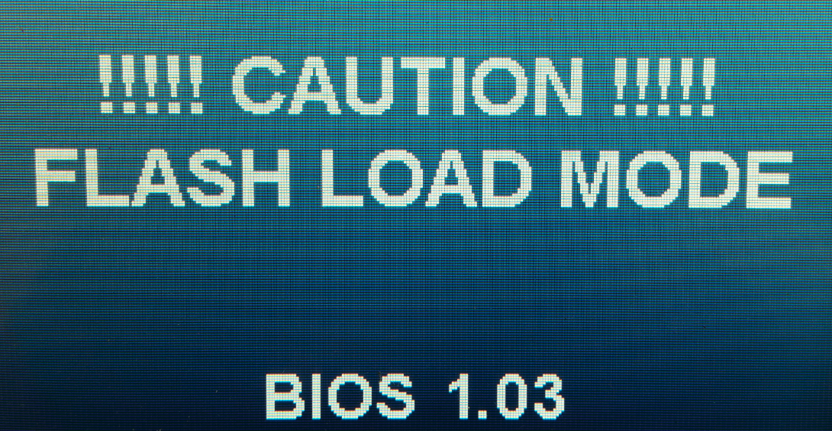
- Next, WinFlash begins to erase the existing flash data in the 4322 in preparation to write the new.
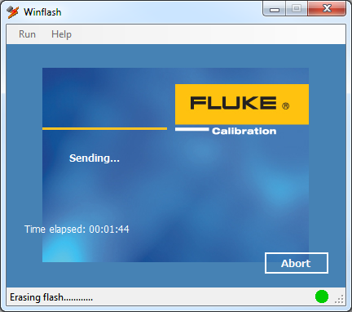
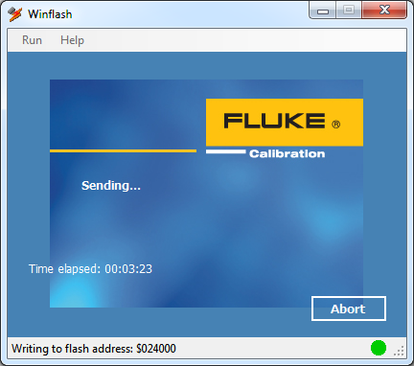
- When the process is complete, a verification window will appear. An upgrade confirmation screen appears on the 4322 with the default answer of “Yes” highlighted with a black background. Press the 4322 [ENTER] key to confirm.
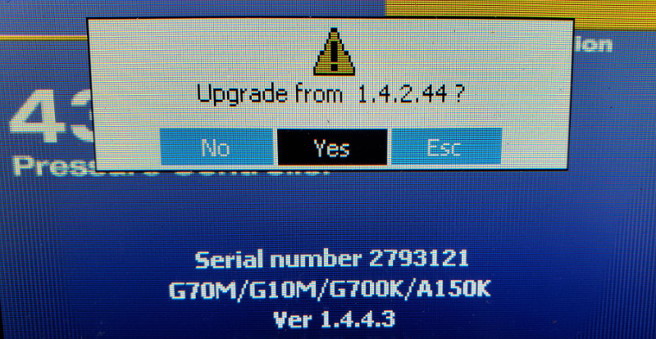
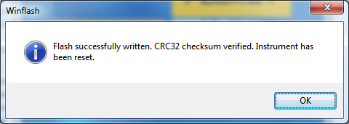

- Cycle the power of the 4322 to continue with the update.
- Press and hold the ESC key to verify the new firmware has been applied.
