**2456-LEM setup in COMPASS for Pressure (or Flow) software**

**Hardware Setup**

1. For direct connection of the 2456-LEM to a computer, set the switch on the back of the 2456-LEM to the RS232 setting.

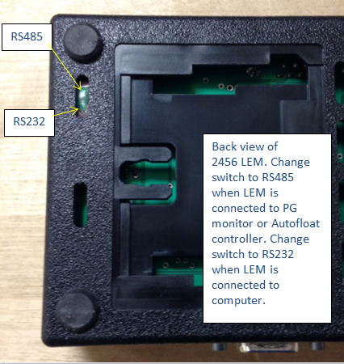



2. With the included DB9 cable, connect the 2456-LEM directly to a DB9 RS232 connection on a computer (or to a RS232 to USB adapter to a computer). The 2456-LEM manual states to use part number 8-826 cable. The Fluke part number for this cable is 3872695. This is a straight through cable with DB9 female ends and is included with the 2456-LEM. The 2456-LEM manual incorrectly states that this has M/F ends (not F/F that it actually has).

3. Connect the included power adapter to power and to the 2456-LEM. The green light on 2456-LEM will come on.

**Setup in COMPASS for Pressure** (same instructions for COMPASS for Flow)

1. Follow this menu path in COMPASS for Pressure to open the Support Device Editor window: [Setup], <Support Device>

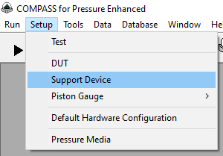

The Support Device Editor will open to the last device that was open in it.

2. Click the blank white piece of paper at the top-right to create a new device.

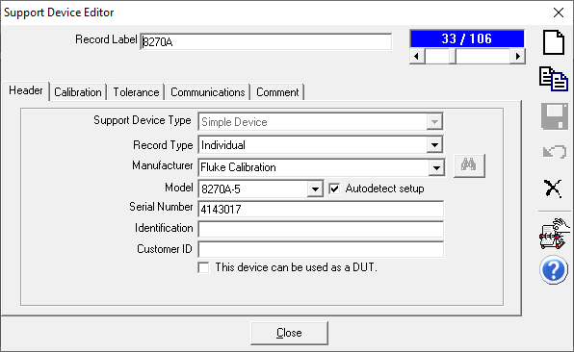

2.

3. Choose “Ruska” in the Manufacturer drop-down list, and “LEM 2456” in the Model drop-down list

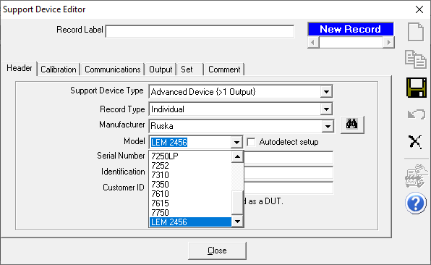

3.

4.

4. Click the binocular icon to search the hidden Example database. The item “Example: Ruska/LEM 2456” should be shown in the window that pops up.

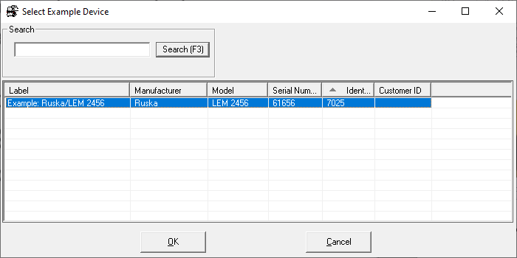

5.

5. Double-click “Example: Ruska/LEM 2456” and the below window will appear as a reminder to check the settings before using this new device. Click the [OK] button to continue.

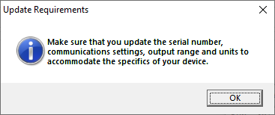

6. Enter a name for the device in the “Record Label” entry box, and the serial number of your 2456-LEM in the “Serial Number” entry box. If you will never calibrate the 2456-LEM using COMPASS for Pressure, then uncheck the box “This device can be used as a DUT”.

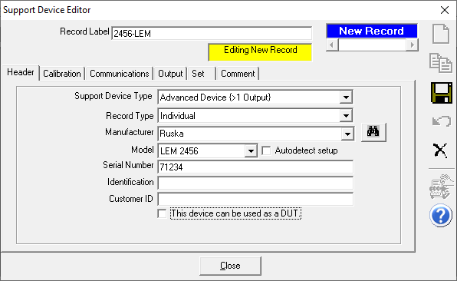

6.

6.

7. The information on the Calibration tab is optional.

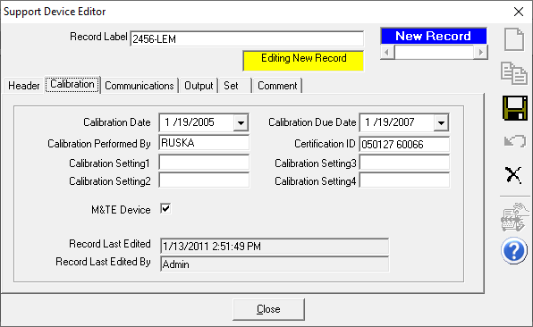

8. On the Communications tab, ensure that the “Data Acquisition Type” is set to RS232, and the other settings are as shown below (Handshaking, Terminators). Click the [Ports] button to choose the COM port on your computer to use and select that on the window that pops up. Ensure that Parity is N (None), Data Bits are 8 and Stop Bit is 1. Click [OK] to close the RS232 Settings window.

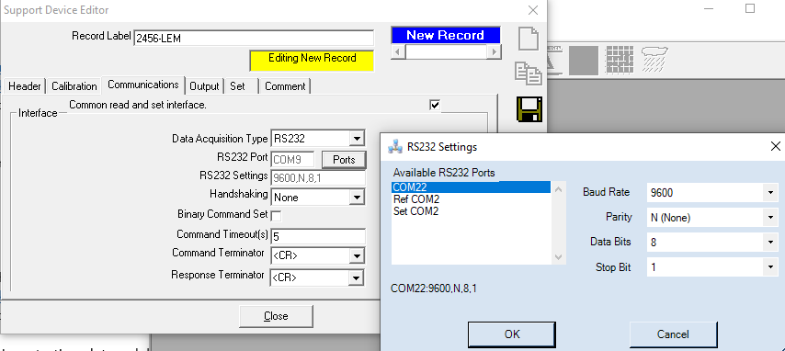

9. Click the diskette icon to save the new device.

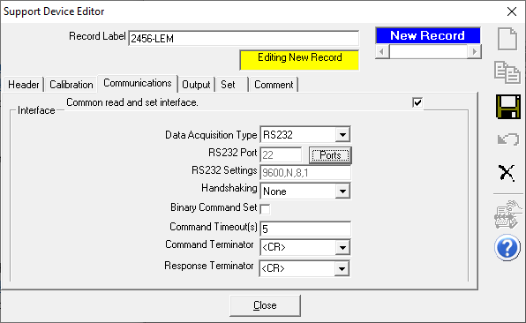

9.

10. The remaining information in this document should not be necessary to setup or use the 2456-LEM in COMPASS unless you encounter error messages or there are problems.

Note that this example assumes that the address of the 2456-LEM is set to the default value of 33. If the address is not 33, then change the macro code to check for the appropriate address (i.e. change 33 to the correct address). Sometimes the address is set to the last two digits of the serial number.

Here’s the line in the macro code that checks for the correct address . If it is not, then the script will not process the reply.

**elseif** **Mid**(Reply,2,2) <> "33" **then**

The Output tab shows that there are three outputs; Ambient Humidity, Ambient Pressure and Ambient Temperature.

Here’s the Output tab with Ambient Humidity highlighted.

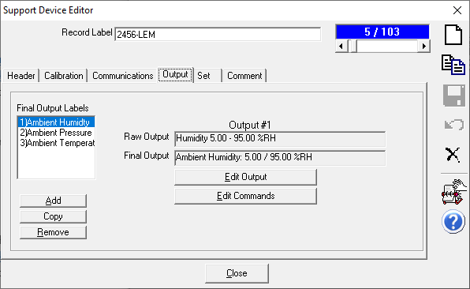

With “Ambient Humidity” highlighted, click the [Edit Output] button to see the **Humidity** output screens

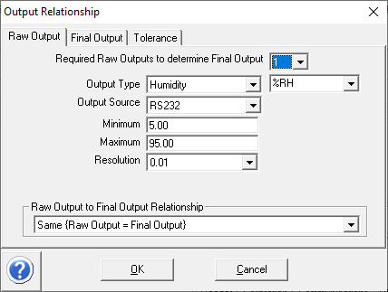

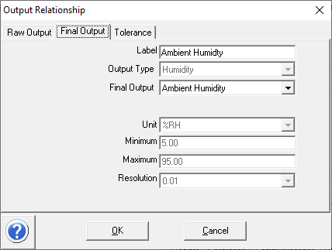

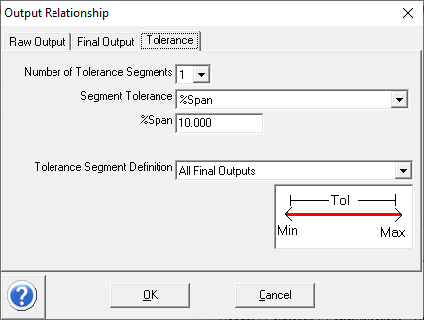

From the Output tab (with Ambient Humidity highlighted), click the [Edit Commands] button to see the command and ReplyParser macro “GetLEM2456Humidity” for humidity.

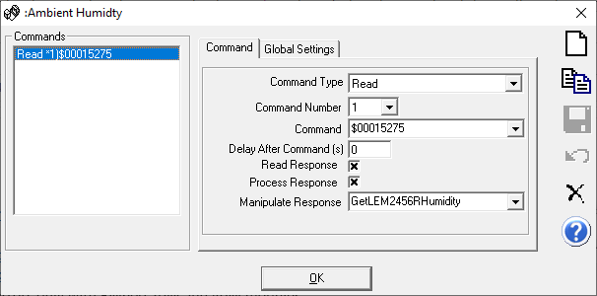

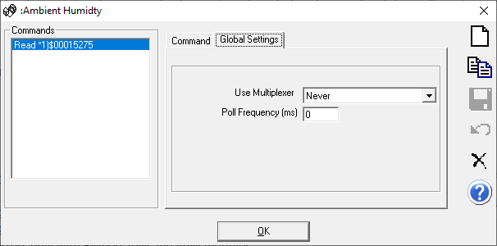

Here’s the Output tab with Ambient Pressure highlighted.

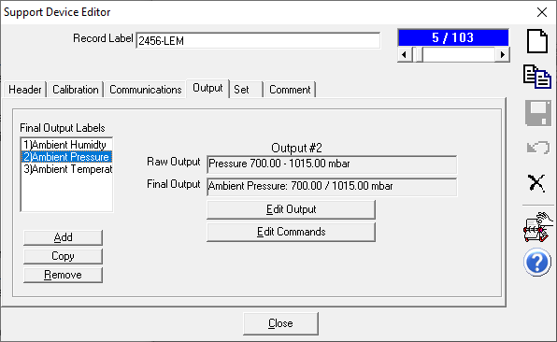

With “Ambient Pressure” highlighted, click the [Edit Output] button to see the **Pressure** output screens

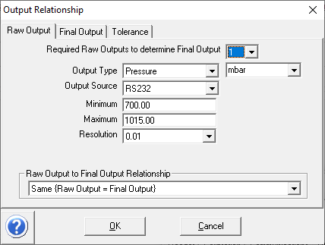

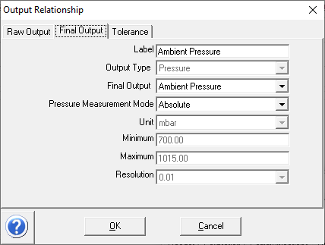

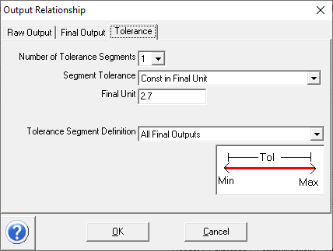

From the Output tab (with Ambient Pressure highlighted), click the [Edit Commands] button to see the command and ReplyParser macro “Get:EM2456Pressure” for Pressure.

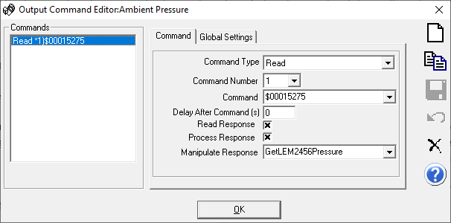

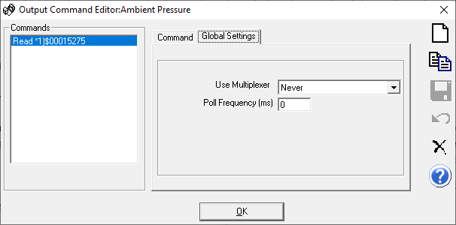

Here’s the Output tab with Ambient Temperature highlighted.

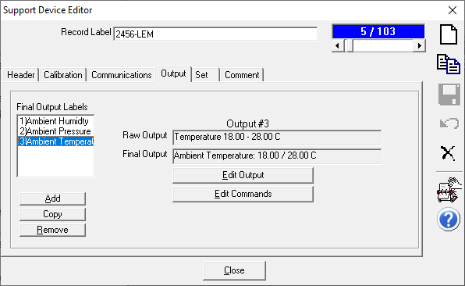

With “Ambient Temperature” highlighted, click the [Edit Output] button to see the **Temperature** output screens

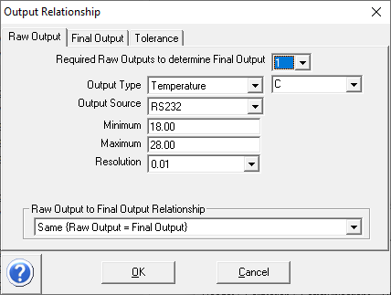

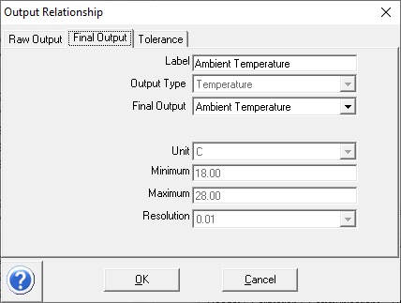

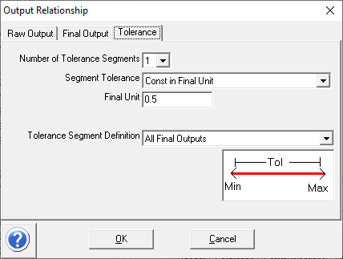

From the Output tab (with Ambient Temperature highlighted), click the [Edit Commands] button to see the command and ReplyParser macro “GetLEM2456Temperature” for temperature.

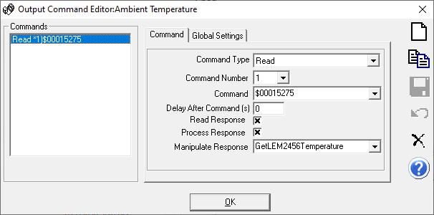

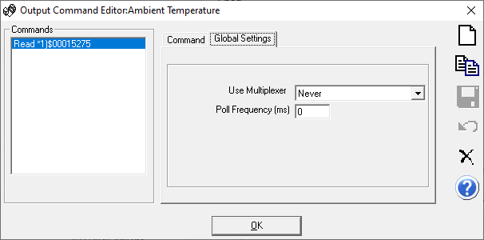

The Set output tab is blank as the 2456-LEM cannot does not have any set or control outputs

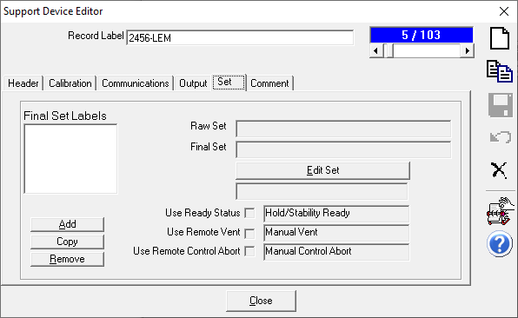

Here’s a view of the run window in COMPASS for Pressure with the Interface Spy window open that shows the commands sent to the 2456-LEM, and the replies.

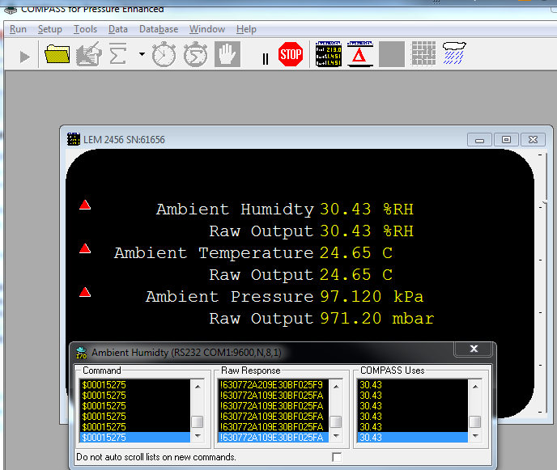

**This is the view in the COMPASS Macro Editor of the Humidity Macro. The text of the macro to copy/paste into a new macro is on the next page. Select the “ReplyParser” folder and click the “New Macro” icon** **to create a new macro. Replace all the text in the new macro with the text on the next page. Name the macro in the Title section the same as the function name (as shown below).**

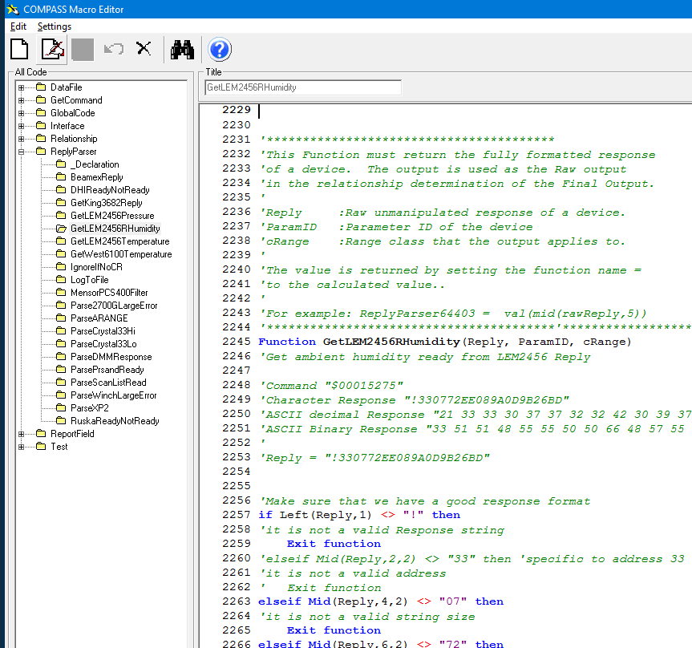

**Function** **GetLEM2456RHumidity**(Reply, ParamID, cRange)

*'Make sure that we have a good response format*

**if** Left(Reply,1) <> "!" **then**

*'it is not a valid Response string*

**Exit** **function**

**elseif** **Mid**(Reply,2,2) <> "33" **then**

*'it is not a valid address*

**Exit** **function**

**elseif** **Mid**(Reply,4,2) <> "07" **then**

*'it is not a valid string size*

**Exit** **function**

**elseif** **Mid**(Reply,6,2) <> "72" **then**

*'it is not a valid command (r) in string*

**Exit** **function**

**elseif** len(reply) <> 21 **then**

*'it is not a valid string len*

**Exit** **function**

**end if**

Rh1 = **Mid**(Reply,12,1)

Rh2 = **Mid**(Reply,13,1)

Rh3 = **Mid**(Reply,14,1)

Rh4 = **Mid**(Reply,15,1)

**Select Case** Rh1

**case** "A"

Base1 = 10

**case** "B"

Base1 = 11

**case** "C"

Base1 = 12

**case** "D"

Base1 = 13

**case** "E"

Base1 = 14

**case** "F"

Base1 = 15

**case** "9"

Base1 = 9

**case** "8"

Base1 = 8

**case** "7"

Base1 = 7

**case** "6"

Base1 = 6

**case** "5"

Base1 = 5

**case** "4"

Base1 = 4

**case** "3"

Base1 = 3

**case** "2"

Base1 = 2

**case** "1"

Base1 = 1

**case** "0"

Base1 = 0

**End Select**

**Select Case** Rh2

**case** "A"

Base2 = 10

**case** "B"

Base2 = 11

**case** "C"

Base2 = 12

**case** "D"

Base2 = 13

**case** "E"

Base2 = 14

**case** "F"

Base2 = 15

**case** "9"

Base2 = 9

**case** "8"

Base2 = 8

**case** "7"

Base2 = 7

**case** "6"

Base2 = 6

**case** "5"

Base2 = 5

**case** "4"

Base2 = 4

**case** "3"

Base2 = 3

**case** "2"

Base2 = 2

**case** "1"

Base2 = 1

**case** "0"

Base2 = 0

**End Select**

**Select Case** Rh3

**case** "A"

Base3 = 10

**case** "B"

Base3 = 11

**case** "C"

Base3 = 12

**case** "D"

Base3 = 13

**case** "E"

Base3 = 14

**case** "F"

Base3 = 15

**case** "9"

Base3 = 9

**case** "8"

Base3 = 8

**case** "7"

Base3 = 7

**case** "6"

Base3 = 6

**case** "5"

Base3 = 5

**case** "4"

Base3 = 4

**case** "3"

Base3 = 3

**case** "2"

Base3 = 2

**case** "1"

Base3 = 1

**case** "0"

Base3 = 0

**End Select**

**Select Case** Rh4

**case** "A"

Base4 = 10

**case** "B"

Base4 = 11

**case** "C"

Base4 = 12

**case** "D"

Base4 = 13

**case** "E"

Base4 = 14

**case** "F"

Base4 = 15

**case** "9"

Base4 = 9

**case** "8"

Base4 = 8

**case** "7"

Base4 = 7

**case** "6"

Base4 = 6

**case** "5"

Base4 = 5

**case** "4"

Base4 = 4

**case** "3"

Base4 = 3

**case** "2"

Base4 = 2

**case** "1"

Base4 = 1

**case** "0"

Base4 = 0

**End Select**

RHumid = (Base1*16)+(Base2*1)+(Base3*4096)+(Base4*256)

*'GetLEM2456RHumidity = Base4*

**GetLEM2456RHumidity** = RHumid / 100

**End Function**

**This is the view in the COMPASS Macro Editor of the Temperature Macro. The text of the macro to copy/paste into a new macro is on the next page.**

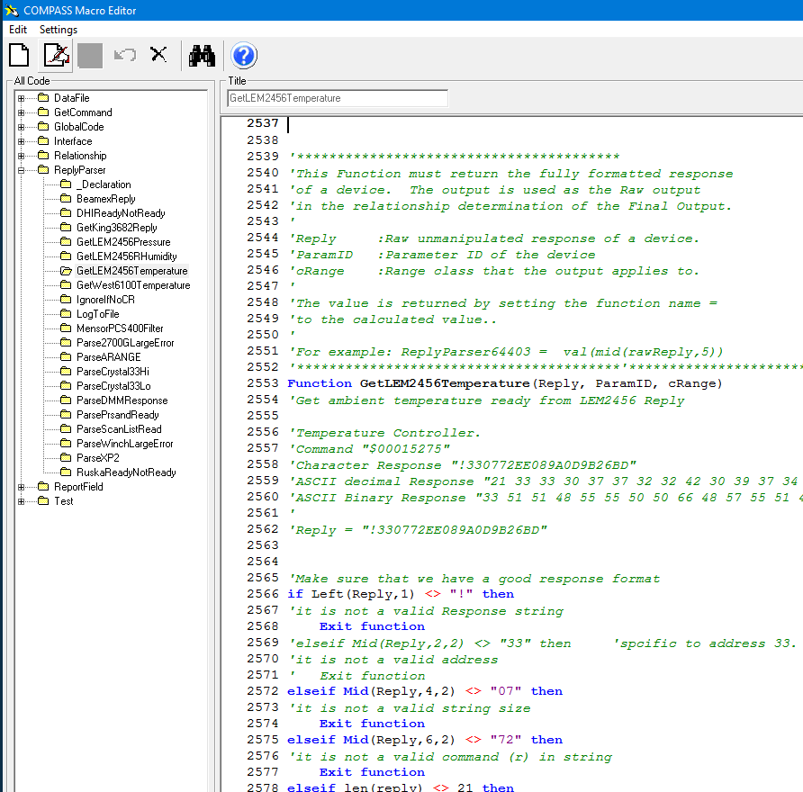

**Function** **GetLEM2456Temperature**(Reply, ParamID, cRange)

*'Make sure that we have a good response format*

**if** Left(Reply,1) <> "!" **then**

*'it is not a valid Response string*

**Exit** **function**

**elseif** **Mid**(Reply,2,2) <> "33" **then**

*'it is not a valid address*

**Exit** **function**

**elseif** **Mid**(Reply,4,2) <> "07" **then**

*'it is not a valid string size*

**Exit** **function**

**elseif** **Mid**(Reply,6,2) <> "72" **then**

*'it is not a valid command (r) in string*

**Exit** **function**

**elseif** len(reply) <> 21 **then**

*'it is not a valid string len*

**Exit** **function**

**end if**

T1 = **Mid**(Reply,8,1)

T2 = **Mid**(Reply,9,1)

T3 = **Mid**(Reply,10,1)

T4 = **Mid**(Reply,11,1)

**Select Case** T1

**case** "A"

Base1 = 10

**case** "B"

Base1 = 11

**case** "C"

Base1 = 12

**case** "D"

Base1 = 13

**case** "E"

Base1 = 14

**case** "F"

Base1 = 15

**case** "9"

Base1 = 9

**case** "8"

Base1 = 8

**case** "7"

Base1 = 7

**case** "6"

Base1 = 6

**case** "5"

Base1 = 5

**case** "4"

Base1 = 4

**case** "3"

Base1 = 3

**case** "2"

Base1 = 2

**case** "1"

Base1 = 1

**case** "0"

Base1 = 0

**End Select**

**Select Case** T2

**case** "A"

Base2 = 10

**case** "B"

Base2 = 11

**case** "C"

Base2 = 12

**case** "D"

Base2 = 13

**case** "E"

Base2 = 14

**case** "F"

Base2 = 15

**case** "9"

Base2 = 9

**case** "8"

Base2 = 8

**case** "7"

Base2 = 7

**case** "6"

Base2 = 6

**case** "5"

Base2 = 5

**case** "4"

Base2 = 4

**case** "3"

Base2 = 3

**case** "2"

Base2 = 2

**case** "1"

Base2 = 1

**case** "0"

Base2 = 0

**End Select**

**Select Case** T3

**case** "A"

Base3 = 10

**case** "B"

Base3 = 11

**case** "C"

Base3 = 12

**case** "D"

Base3 = 13

**case** "E"

Base3 = 14

**case** "F"

Base3 = 15

**case** "9"

Base3 = 9

**case** "8"

Base3 = 8

**case** "7"

Base3 = 7

**case** "6"

Base3 = 6

**case** "5"

Base3 = 5

**case** "4"

Base3 = 4

**case** "3"

Base3 = 3

**case** "2"

Base3 = 2

**case** "1"

Base3 = 1

**case** "0"

Base3 = 0

**End Select**

**Select Case** T4

**case** "A"

Base4 = 10

**case** "B"

Base4 = 11

**case** "C"

Base4 = 12

**case** "D"

Base4 = 13

**case** "E"

Base4 = 14

**case** "F"

Base4 = 15

**case** "9"

Base4 = 9

**case** "8"

Base4 = 8

**case** "7"

Base4 = 7

**case** "6"

Base4 = 6

**case** "5"

Base4 = 5

**case** "4"

Base4 = 4

**case** "3"

Base4 = 3

**case** "2"

Base4 = 2

**case** "1"

Base4 = 1

**case** "0"

Base4 = 0

**End Select**

temp = (Base1*16)+(Base2*1)+(Base3*4096)+(Base4*256)

*'GetLEM2456Temperature = Base4*

**GetLEM2456Temperature** = temp / 100

**End Function**

**This is the view in the COMPASS Macro Editor of the Pressure Macro. The text of the macro to copy/paste into a new macro is on the next page.**

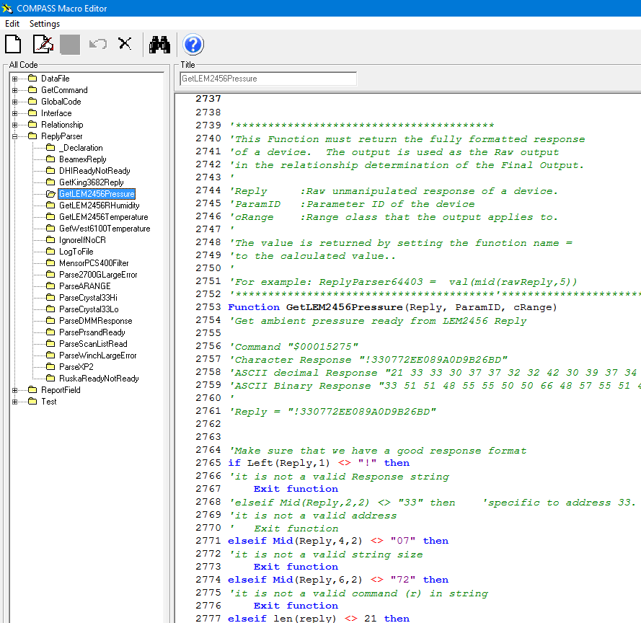

**Function** **GetLEM2456Pressure**(Reply, ParamID, cRange)

*'Make sure that we have a good response format*

**if** Left(Reply,1) <> "!" **then**

*'it is not a valid Response string*

**Exit** **function**

**elseif** **Mid**(Reply,2,2) <> "33" **then**

*'it is not a valid address*

**Exit** **function**

**elseif** **Mid**(Reply,4,2) <> "07" **then**

*'it is not a valid string size*

**Exit** **function**

**elseif** **Mid**(Reply,6,2) <> "72" **then**

*'it is not a valid command (r) in string*

**Exit** **function**

**elseif** len(reply) <> 21 **then**

*'it is not a valid string len*

**Exit** **function**

**end if**

P1 = **Mid**(Reply,16,1)

P2 = **Mid**(Reply,17,1)

P3 = **Mid**(Reply,18,1)

P4 = **Mid**(Reply,19,1)

**Select Case** P1

**case** "A"

Base1 = 10

**case** "B"

Base1 = 11

**case** "C"

Base1 = 12

**case** "D"

Base1 = 13

**case** "E"

Base1 = 14

**case** "F"

Base1 = 15

**case** "9"

Base1 = 9

**case** "8"

Base1 = 8

**case** "7"

Base1 = 7

**case** "6"

Base1 = 6

**case** "5"

Base1 = 5

**case** "4"

Base1 = 4

**case** "3"

Base1 = 3

**case** "2"

Base1 = 2

**case** "1"

Base1 = 1

**case** "0"

Base1 = 0

**End Select**

**Select Case** P2

**case** "A"

Base2 = 10

**case** "B"

Base2 = 11

**case** "C"

Base2 = 12

**case** "D"

Base2 = 13

**case** "E"

Base2 = 14

**case** "F"

Base2 = 15

**case** "9"

Base2 = 9

**case** "8"

Base2 = 8

**case** "7"

Base2 = 7

**case** "6"

Base2 = 6

**case** "5"

Base2 = 5

**case** "4"

Base2 = 4

**case** "3"

Base2 = 3

**case** "2"

Base2 = 2

**case** "1"

Base2 = 1

**case** "0"

Base2 = 0

**End Select**

**Select Case** P3

**case** "A"

Base3 = 10

**case** "B"

Base3 = 11

**case** "C"

Base3 = 12

**case** "D"

Base3 = 13

**case** "E"

Base3 = 14

**case** "F"

Base3 = 15

**case** "9"

Base3 = 9

**case** "8"

Base3 = 8

**case** "7"

Base3 = 7

**case** "6"

Base3 = 6

**case** "5"

Base3 = 5

**case** "4"

Base3 = 4

**case** "3"

Base3 = 3

**case** "2"

Base3 = 2

**case** "1"

Base3 = 1

**case** "0"

Base3 = 0

**End Select**

**Select Case** P4

**case** "A"

Base4 = 10

**case** "B"

Base4 = 11

**case** "C"

Base4 = 12

**case** "D"

Base4 = 13

**case** "E"

Base4 = 14

**case** "F"

Base4 = 15

**case** "9"

Base4 = 9

**case** "8"

Base4 = 8

**case** "7"

Base4 = 7

**case** "6"

Base4 = 6

**case** "5"

Base4 = 5

**case** "4"

Base4 = 4

**case** "3"

Base4 = 3

**case** "2"

Base4 = 2

**case** "1"

Base4 = 1

**case** "0"

Base4 = 0

**End Select**

press = (Base1*16)+(Base2*1)+(Base3*4096)+(Base4*256)

*'GetLEM2456Pressure = Base4*

**GetLEM2456Pressure** = press / 10

**End Function**