To solve the no license available error, log into Met/Track as the “MT” user.

Click on “Setup” then “Licenses”.

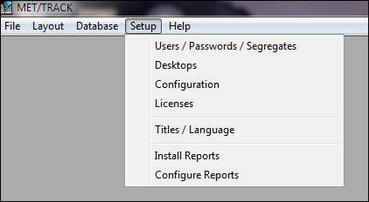

The next screen tells you how many licenses you have, the type of license, and how many are in use.

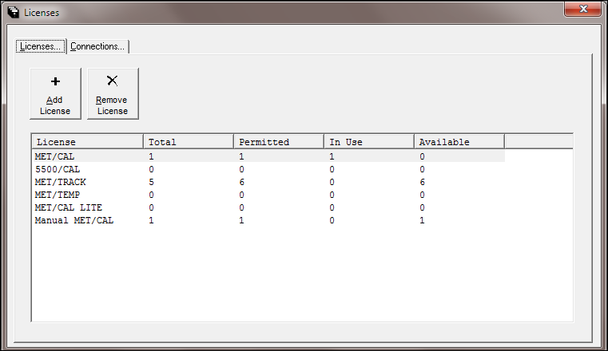

Click on the “Connections” tab.  This screen shows the users that are connected and the application they are using.

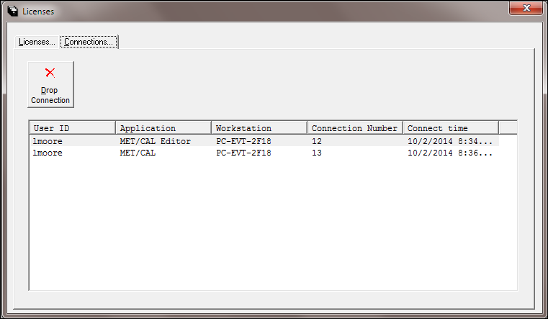

\*\*\*\*\*\*\*\*THIS PART IS VERY IMPORTANT!!!!\*\*\*\*\*\*\*\*

\*\*\*\*You must ensure that the connection you are going to drop is in fact hung up or not in use.  If you drop a connection that is in use that operator will be disconnected from the database and they will lose all of the work they are working on.\*\*\*\*

Select the user connection that needs to be dropped and press the “Drop Connection” button.  This will drop the connection between that workstation and the database freeing up that license.