***How to configure a Hydra, NetDaq or 2680 series Daq model for use with Transducers (pressure, humidity, etc.)***

First you need to determine what will be coming in to the Daq input connector. It is typically 0-10 V, 0-5 V, 0-20 mA, or 4-20 mA. Your transducer specifications will tell you the input and output of unit.

Physical connection

Voltage:

Simply connect the high and low wires coming from the pressure transducer to the high and low terminals on the desired channel of the universal input connector.

Current:

You will need a current shunt to convert the current coming in from the transducer to voltage. Fluke has a readily available set, part number 2620A-101. These shunts, shown below, have a 10 Ohm rating and are designed to work within the input connector for any current source 0-100 mA. However you can use any shunt of the correct value for your application. (See ***note*** on page 4)

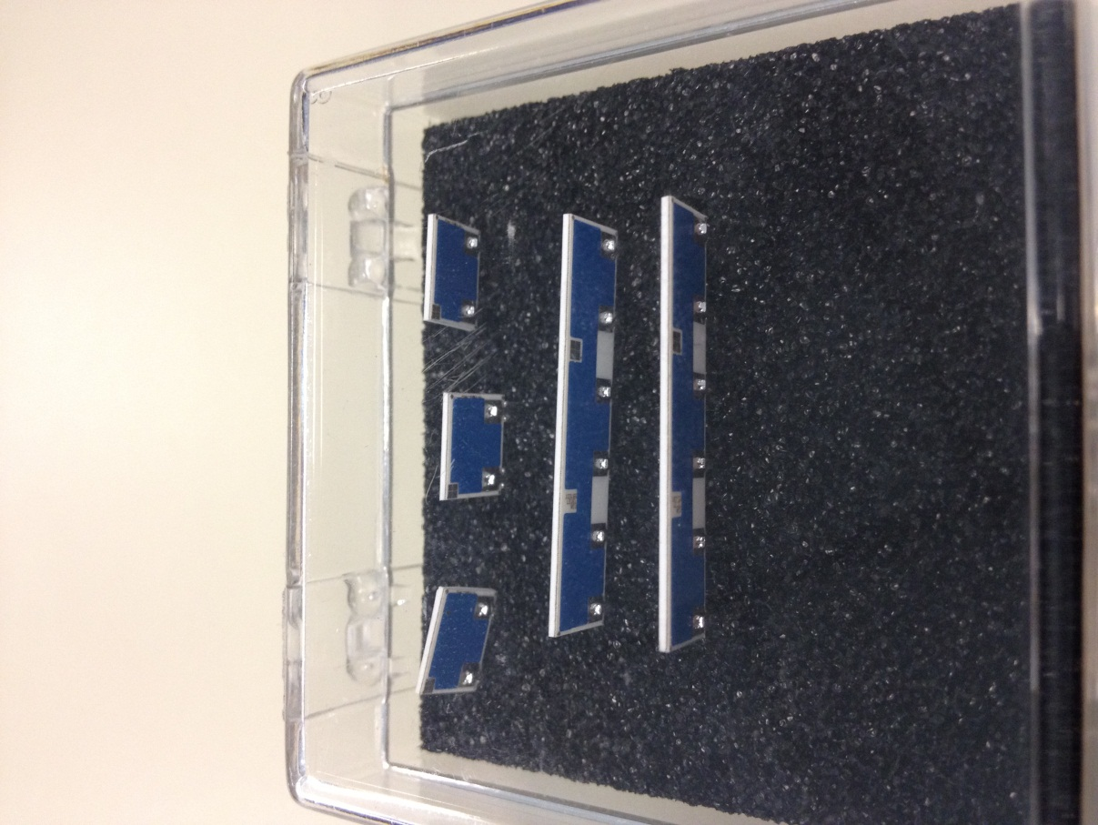

Connect the shunt and then connect the wires into the same terminals, just right on top of the shunt as shown:

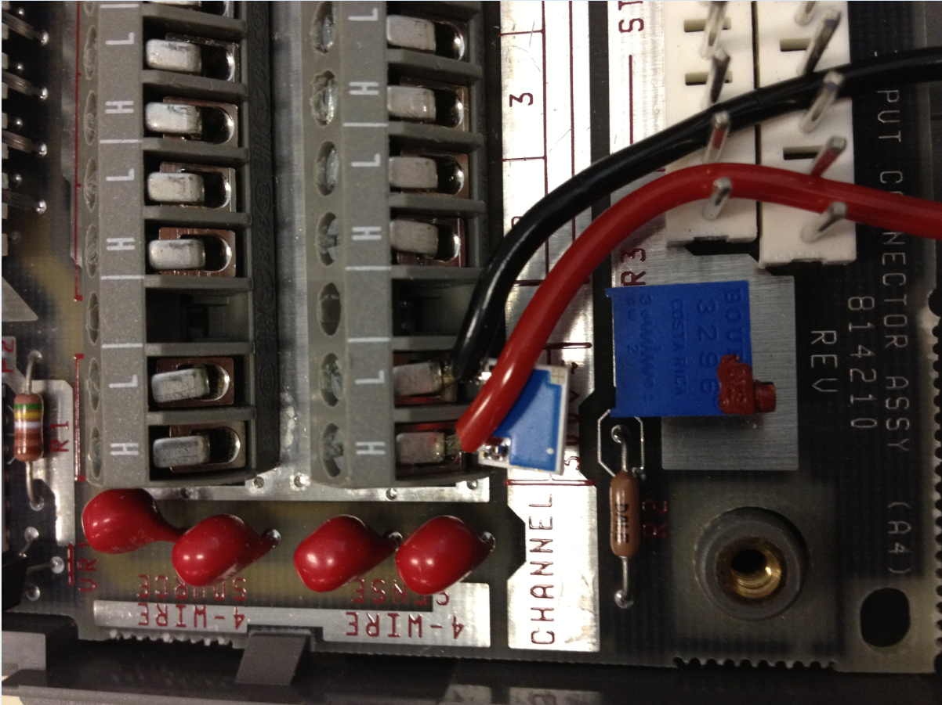

Figure 1: Setup for Current, using a shunt:

Now to configure the channel with the software:

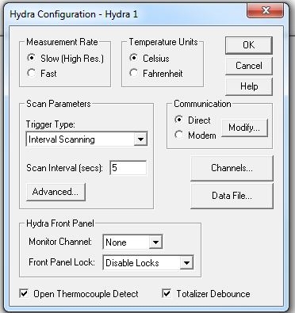

Click the “Channels” button. Highlight the channel you want to configure and then click “Function”

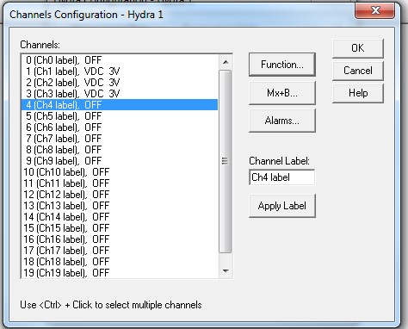

Select “VDC” and “auto” for the range, or the appropriate range for your instrument, and type in the Units in “PSI” or whatever units your transducer will display then click “OK”.

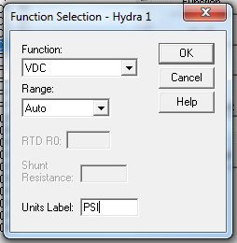

Select the Mx+B button.

Select “Calculate Mx+B from point values”

**If the value coming in to your Daq system is Current**

You are using a current shunt so the DAQ is reading voltage. (4-20mA or other current input) *CALCULATE* the Minimum and Maximum values for the Input range using Ohms law. (E = I x R).

***Note:*** *The voltage value must comply with the limits of the DAQ – so keep this in mind when choosing a current shunt.*

Example: I have a 10 Ohm resistor and my transducer it putting 4-20 mA into my DAQ system.

0.004 X 10 = 0.04

And

0.020 X 10 = .2

So now I will enter 0.04 in the minimum Input Range field and .2 into the maximum input field.

Then I will find the lower and upper display range of the transducer and input that into the Display Range fields.

So if my transducer will measure 0-30 PSI I will enter 0 in the minimum field and 30 in the maximum field.

Click OK.

**If the value coming in to your Daq system is Voltage**

(0-10V, 0-5V, etc.)

You will configure your Software channel like above, except you will simply enter the lower and upper input ranges and the Minimum and Maximum display ranges of the transducer. The DAQ is reading straight Voltage so you will not have to do any manual calculations.

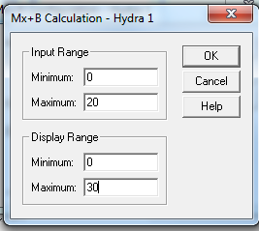

Click OK. Run a test.