***PG7601 Negative Gauge/Differential Setpoint Procedure via RPM4 Offset***

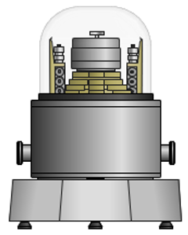 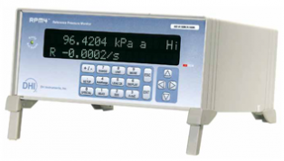

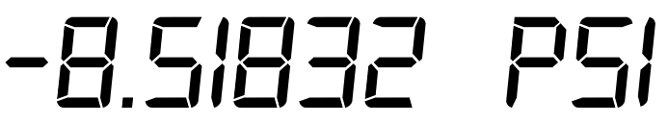

This mode of operation is not possible using COMPASS or similar. It can only be run using the PG terminal buttons. However, if the PG7601 is an automated system it will still automatically load masses and float the piston assuming AutoGen is turned on as if other standard measurement modes were being used.

An RPM3 can also be used with no changes to the below procedure. Some other 3rd party high accuracy barometers can be used if refer to section 3.10 and 3.11.5.4 in the PG7000 Operation Manual.

The 10kPa/kg piston would typically be used for operating in this mode as it’s the lowest pressure piston that cover negative gauge and low positive gauge setpoints.

*** It is important to follow the below steps in order or could result in not being able to establish communications between the RPM4 and PG7601

* Initial RPM4 Setup
  1. Use the Range button to select the A100k range or use the lowest absolute range available that you have determined is acceptable for your testing requirements.
  2. Go to the menu Special🡪 Remote🡪 COM1 and record the RS232 settings or set them to a standardized setup such as 9600, N, 8, and 1.
  3. Connect a modem/straight through type RS232 cable from RPM4 COM1 to PG7601 COM2.
* Initial PG7601 Setup
  1. Go to menu Special🡪 Remote🡪 COM2 and verify it is set to the same settings as recorded above for RPM4 COM1, such as 9600,N, 8, and 1.
  2. Go into the menu Setup🡪 Select🡪 and switch the current setup from #01 to #02 using the arrow key.
     1. Go back to the Setup menu and verify it now shows “Current Setup: #02” to confirm the #02 setup is active.
     2. Can now select Edit to make changes to the #02 Setup.
        1. Within the Edit screen select the first menu for “atmP” which is the ambient pressure selection
           1. Select the fourth option for “COM2”
           2. The PG will automatically try to establish communications with the RPM4 and produce an error message if it is not able to. If there is an error it likely due to either mis-matched COM settings or the wrong cable type being used.
        2. Go back to the Edit screen and select the number five option for “g” which is the gravity selection.
           1. Select the first option “local” to ensure it will use the same gravity value that is stored in the menu Special🡪GL which is Local Gravity. This is the value it normally uses when on setup #01.
* PG7601 Operation
  1. Makes sure RPM4 COM1 is already connected to PG7601 COM2 using a standard modem/straight through type RS232 cable and the COM settings match as described above.
  2. Go to the Setup menu and it will normally display “Current Setup: #01” at the top. Use the Select option to switch it to setup #02.
     1. This should cause the PG to initialize communications with the RPM4 and should see the remote light turn on within the RPM4 front panel.
  3. Press the Mode button and select number four “dif” mode.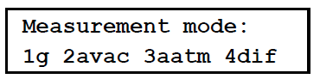
  4. Select the number one option “run” and the current offset value will be shown. 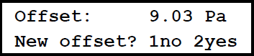
  5. A new offset value needs to be calculated so select number two “yes”.
  6. The current RPM4 pressure will be read and displayed. This value should be very close to your current atmospheric pressure. 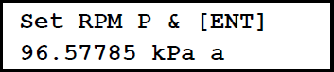
  7. Temporarily plumb the RPM4 Test + port to the PG7601 Test port so the current pressure offset can be determined.
     1. Do not use any self-sealing quick connect fittings as later the RPM4 will be disconnected and its Test port must be open and un-restricted to atmosphere. If sealed or restricted it will produce measurement error.
     2. Press the Head button on the RPM4 to check its head height value. Elevate the RPM4 so that it is at the same height as the PG7601 reference and set the value to 0 or properly set it to the head difference (if the PG7601 is lower than it would be a negative value and higher would be a positive value).
  8. Press the Enter button on the keypad to proceed with the PG7601 floating a pressure close to this value to compare to the RPM4 reading.
     1. If the PG7601 system is automated with AutoGen activated the masses will be loaded and floated automatically.
     2. If the PG7601 system is manually operated a window will appear for proper mass to be loaded. Press the “ENT” button on the keypad when done. 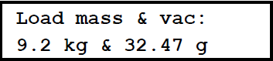
  9. Allow the PG7601 to float the masses automatically or adjust the system manually until all three asterix are shown in the upper left corner of the display per standard operation. 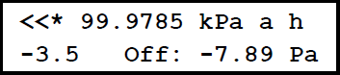
  10. Once the piston is floating in proper Ready states press the “ENT” button on the terminal to record the new offset.
  11. A confirmation window showing the old and new offset will appear. 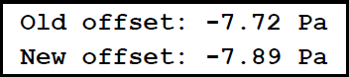
  12. Press the “ENT” button on the keypad to accept the new offset.
      1. Note this value is only stored in the PG7601 memory for use. The RPM4 calibration coefficients are not changed.
  13. Disconnect the RPM4 plumbing so that its Test port is open and unrestricted to atmospheric pressure.
      1. Keep it connected and communicating via the RS232 connection as it is still used to compensate for barometric changes while running setpoints
  14. Connect your Negative Gauge DUT to the PG7601 Test port.
      1. There are multiple head heights in play since the RPM4 is still in use, so it is best to also elevate the DUT to the PG reference level or use the Head button on the PG terminal to define the proper head correction (if the DUT is lower it would be a negative value and if higher would be a positive value).
  15. The PG7601 screen will have changed to the standard screen normally used for setting pressures.
  16. Use the “ENT/SET P” button to start setting negative gauge/differential setpoints and float the piston per standard procedures.
      1. For example, entering a value of -5 would produce a negative gauge mode target of say -5 PSIg. The PG7601 will float the closest pressure to this it can achieve and display the actual pressure with all necessary offsets applied.
      2. Positive gauge mode setpoints can also be run if desired. For example, just entering 5 would produce say 5 PSIg. Note, since the PG7601 has a separate gauge mode that does not use the RPM4 you would be adding some additional uncertainty using this Differential mode. It can be convenient so that don’t have to switch back and do a separate run for the positive gauge mode points if say calibrating a compound gauge.

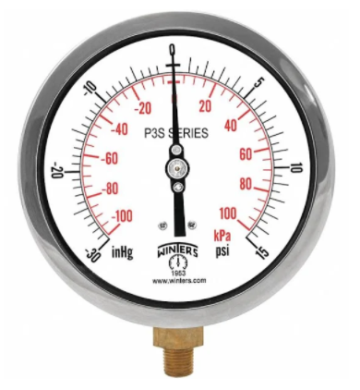

* 1. When Negative Gauge/Differential testing is complete it is important to remember to change back to Setup #01. Go to Setup🡪 Select and change back to #01.
     1. Note, if your RPM4 that will be dedicated for PG7601 use it would not require switching the Setup selection as the RPM4 can remain connected to use instead of the lower accuracy internal barometer the PG7601 system normally uses in other measurement modes.